

**PRIVATE CLINIC SYSTEM**

**Final Release Document**

– Da Nang, November 2024 –

**Table of Contents**

I. Deliverable Package 3

II. Installation Guides 3

1. Backend - ASP.Net core Web Api installation guides 3

2. Backend - FormService NodeJS-ExpressJS installation guides 4

3. Front-End - PClinic Client installation guides 5

4. Front-End - PClinic Admin installation guides 5

III. User Manual 5

1. Overview 5

2. Workflow - Register 5

3. Workflow - Login 7

4. Workflow - Forgot password 8

5. Workflow - Send a contact 10

6. Workflow - Make an appointment 11

7. Workflow - Make online consultant 17

8. Workflow - Treatment and medical report 24

9. Workflow - Treatment history 28

10. Workflow - Manage warehouse 30

11. Workflow - Manage clinic 33

12. Workflow - Medical Articles 36

# I. Deliverable Package

| **No.** | **File** | **Notes** |
| --- | --- | --- |
| 1 | G3_PCS_final.sql | Database, including both table structures and table data |
| 2 | G3_PCS_SRS_final.docx | Final SRS (Requirement) Document |
| 3 | G3_PCS _SDS_final.docx | Final SDS (Design) Document |
| 4 | G3_PCS_Project Tracking | Project tracking for a whole |
| 5 | XYZ_Issues Report.xlsx | Final issues tracking list of the whole project |
| 6 | G3_PCS_Final_Release.docx | Final Project Release Document |

*G3_PCS include the student’s group code & project code*

Other related deliverables:

* Tagged source codes:
* PCLINIC - ASP.Net core Web Api source code: [github.com/5AETEAM-FPTU/ClinicProject_FE_Admin](https://github.com/5AETEAM-FPTU/ClinicProject_FE_Admin)
* PCLINIC - Form Service NodeJS-ExpressJS source code:

[github.com/5AETEAM-FPTU/ClinicProject_ServiceForms_Nodejs_Api](https://github.com/5AETEAM-FPTU/ClinicProject_ServiceForms_Nodejs_Api)

* PCLINIC - Client Front End:

[github.com/5AETEAM-FPTU/ClinicProject_FE](https://github.com/5AETEAM-FPTU/ClinicProject_FE)

* PCLINIC - Admin Front End:

[github.com/5AETEAM-FPTU/ClinicProject_FE_Admin](https://github.com/5AETEAM-FPTU/ClinicProject_FE_Admin)

* Demonstration video: <<YouTube link>>

# II. Installation Guides

## 1. Backend - ASP.Net core Web Api installation guides

1.1 Clone the git repository

1.2 Open the project after the clone successfully

1.3 Adding appsettings.json for environment

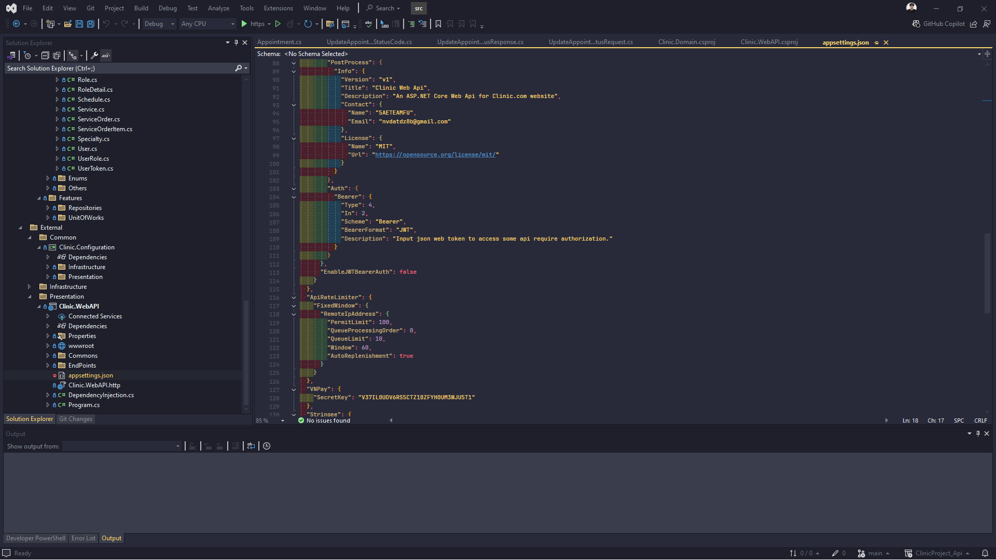

1.4 Select the startup project

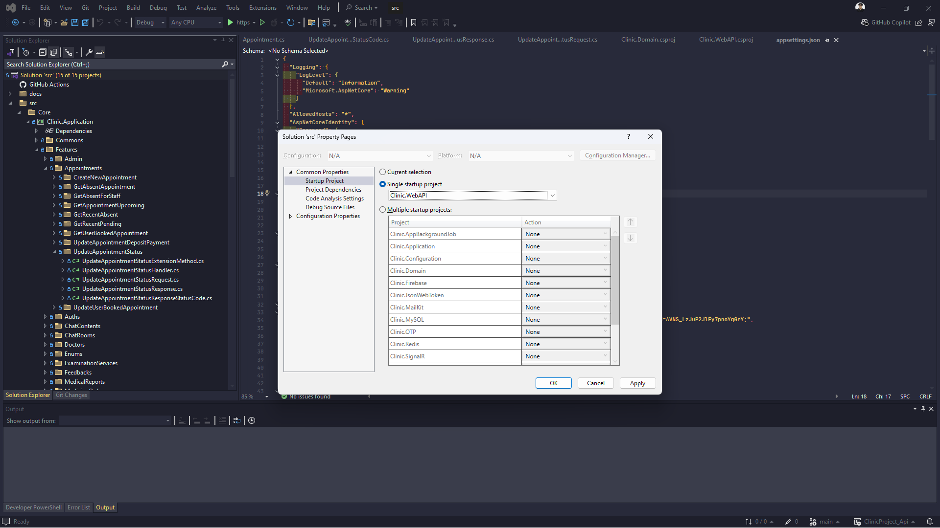

1.5 Click run button to the Back-End project on local

## 2. Backend - FormService NodeJS-ExpressJS installation guides

2.1 Clone the git repository

2.2 Open project and install node package libraries by command: npm install

2.3 Adding .env file for environment

2.4 Type command npm run dev to run the project on local

## 3. Front-End - PClinic Client installation guides

3.1 Clone the git repository

3.2 Open project and install node packet libraries by command: *$npm install*

3.3 Adding .env.local file for environment

3.4 Type command *$npm run dev* to run the project on local

## 4. Front-End - PClinic Admin installation guides

4.1 Clone the git repository

4.2 Open project and install node packet libraries by command: *$npm install*

4.3 Adding .env.local file for environment

4.4 Type command *$npm run dev* to run the project on local

# III. User Manual

## 1. Overview

The Private Clinic Management System is designed to streamline the operations of private healthcare clinics by allowing doctors, staff, and patients to connect and manage clinic services efficiently from any location. This system aims to provide doctors with the flexibility to manage appointments, patient records, and prescriptions while enabling online consultations from the comfort of their homes. For patients, the system simplifies the process of scheduling appointments, ordering medicines, and communicating with healthcare providers remotely.

## 2. Workflow - Register

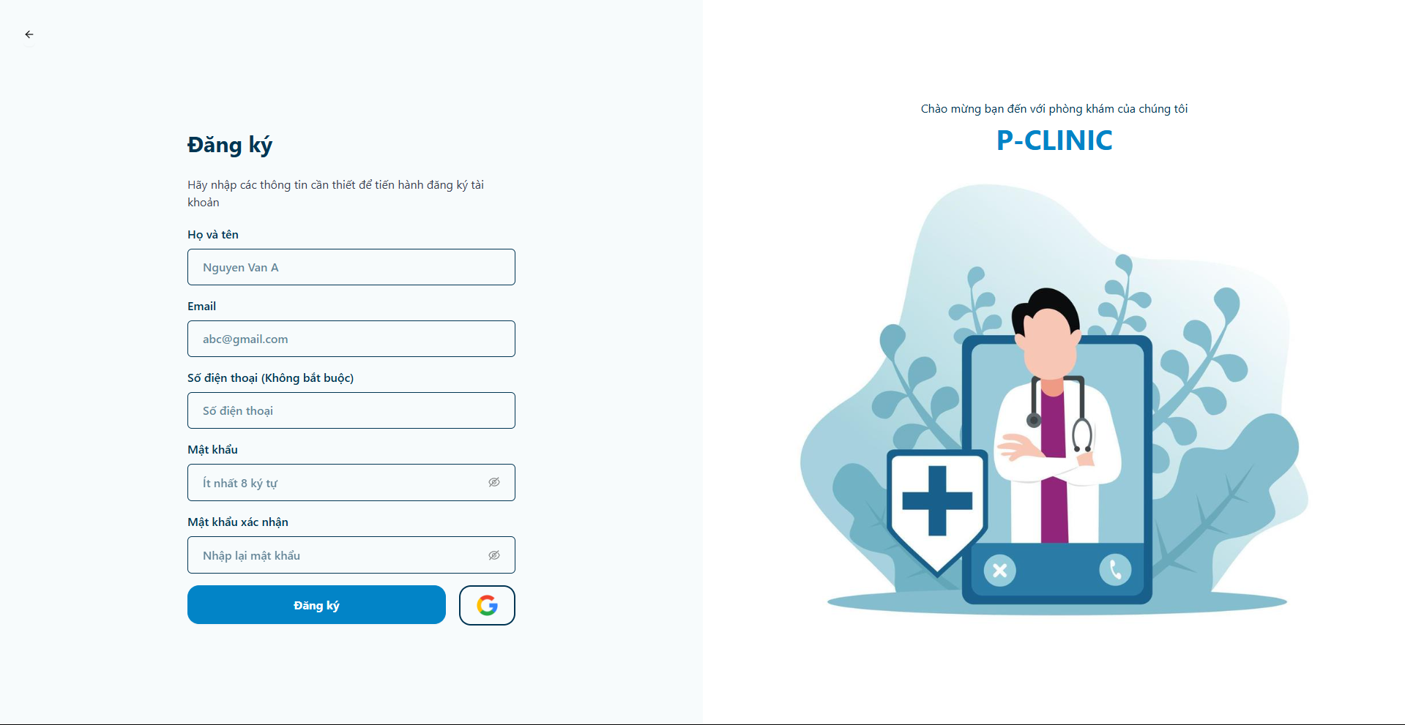

* Register form

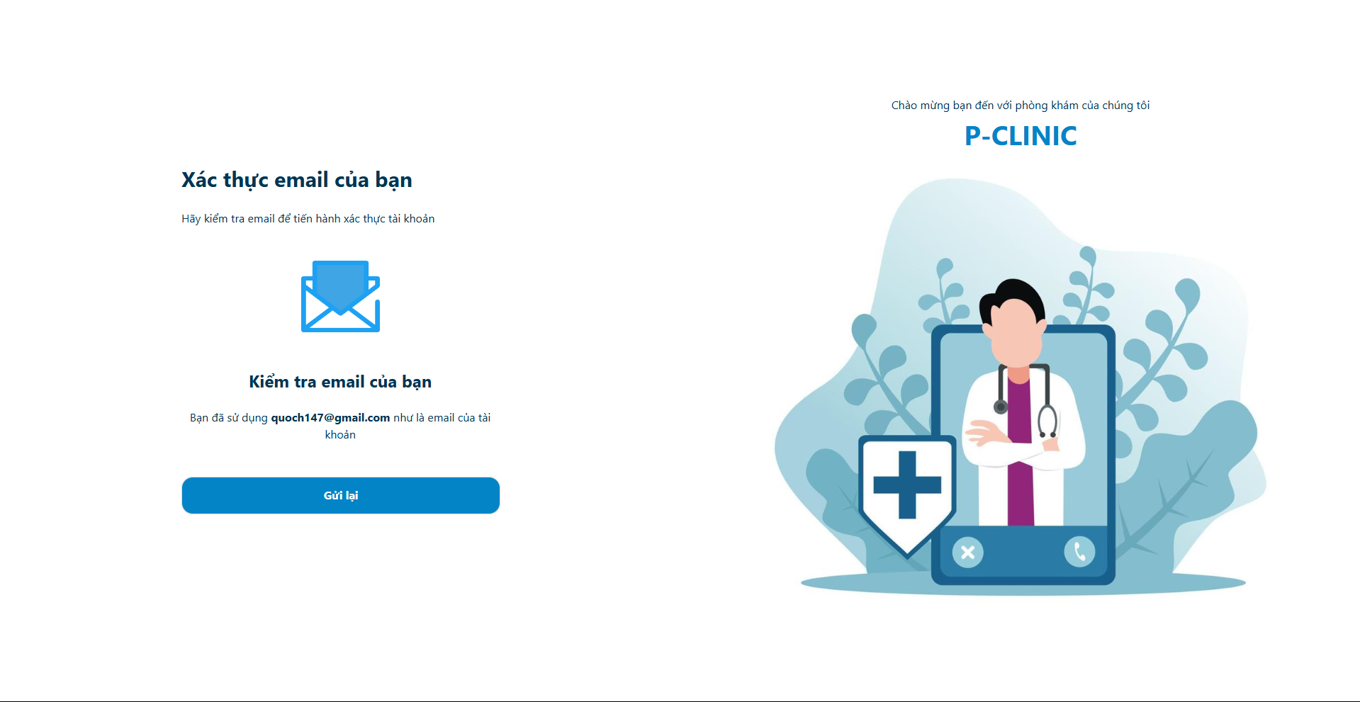

* Check email and confirm

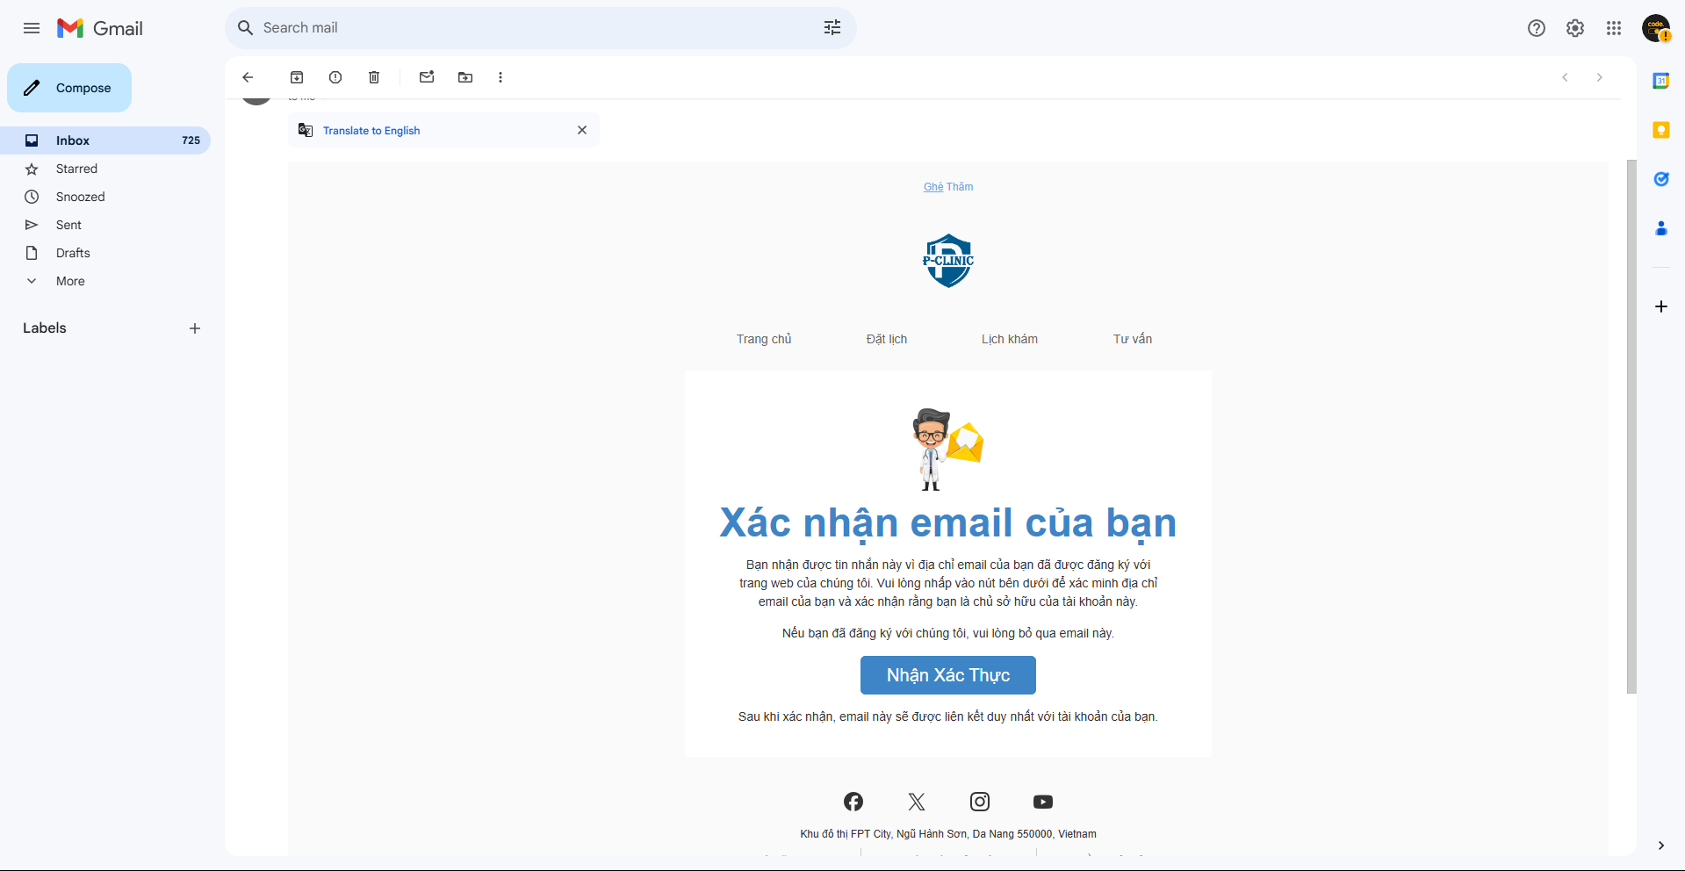



* After confirm successful

## 3. Workflow - Login

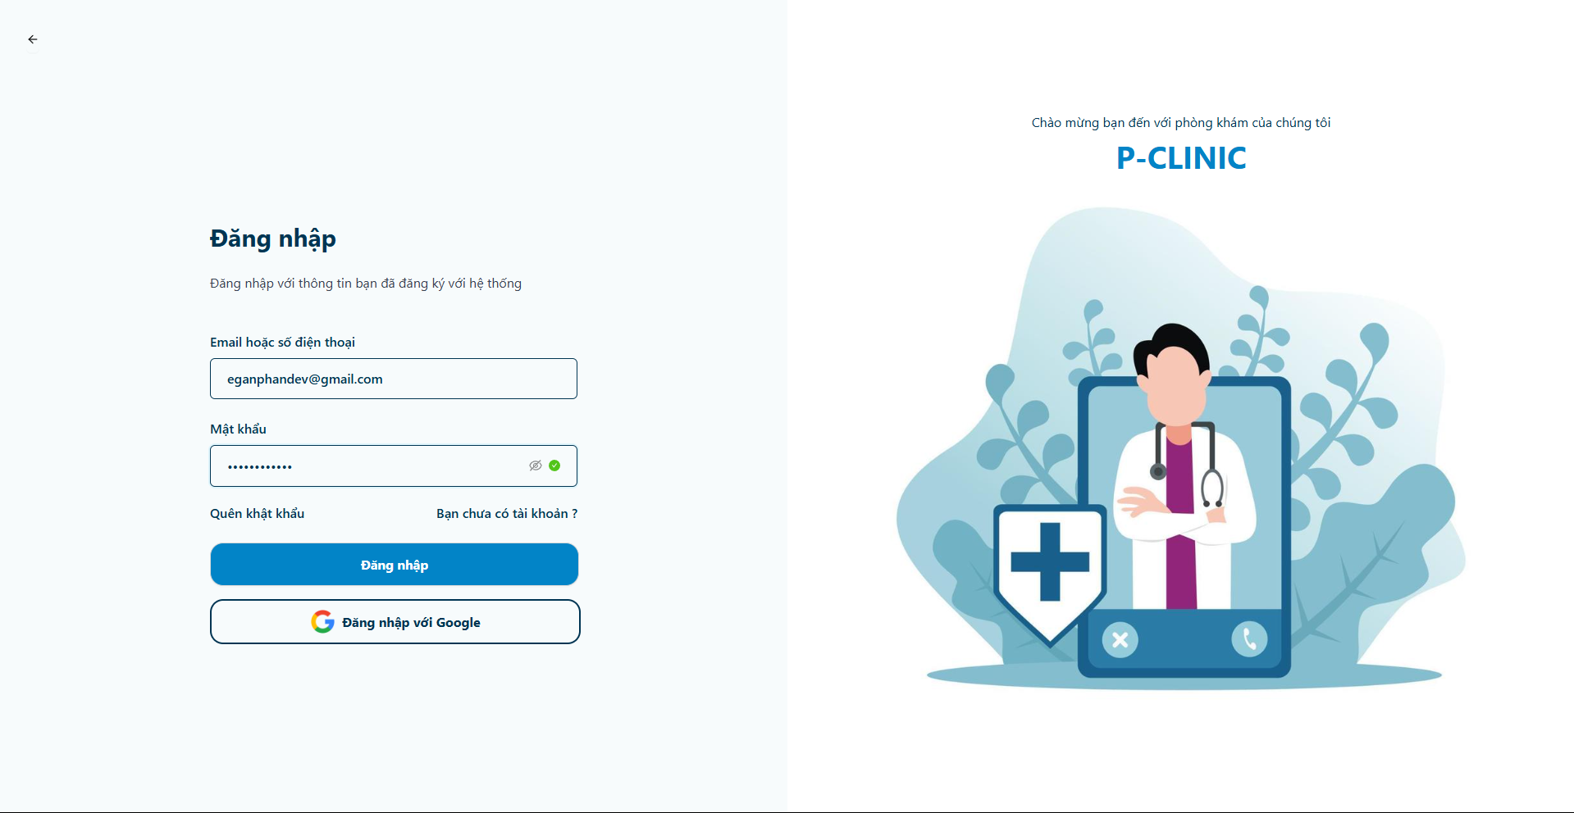

* Enter new registry account

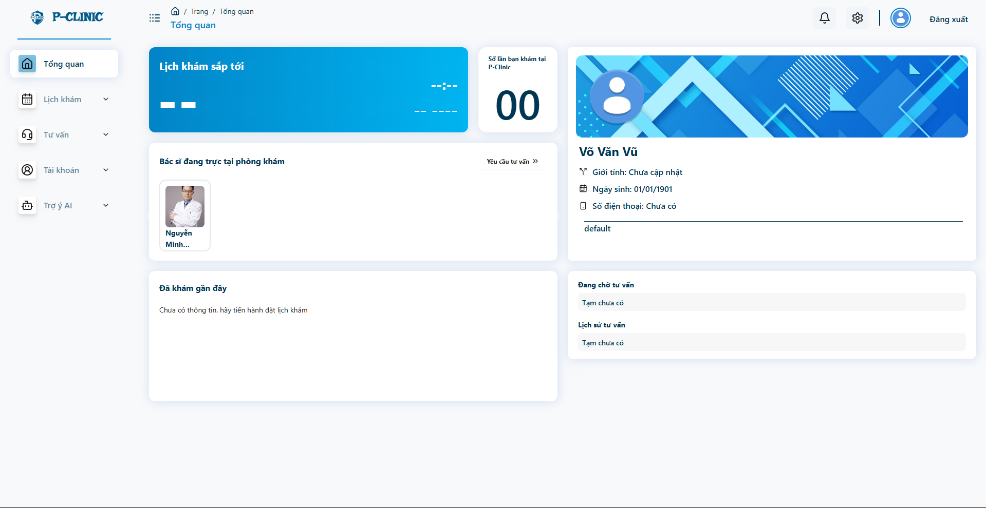

* The first look after login successful

## 4. Workflow - Forgot password

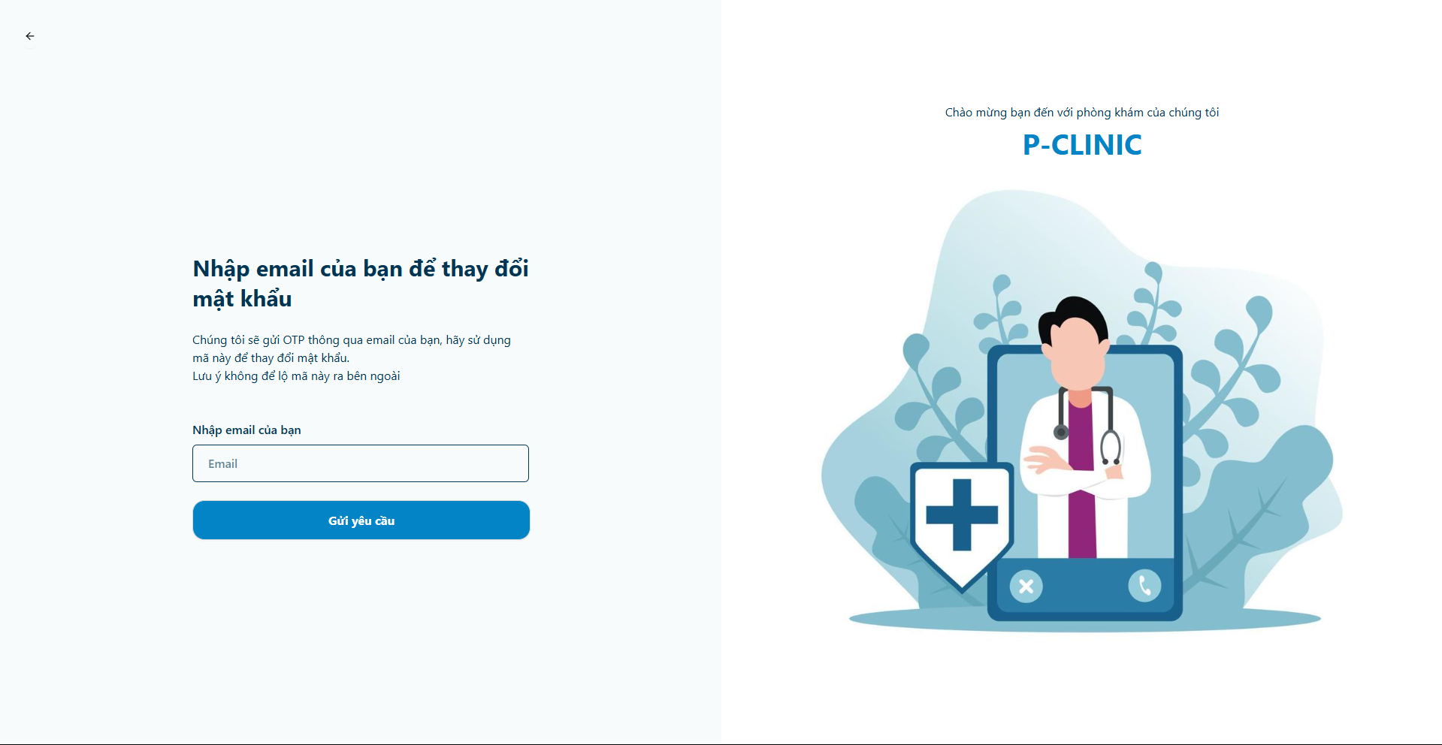

* Enter email to send a request for resetting password



* Check email and remember OTP Code

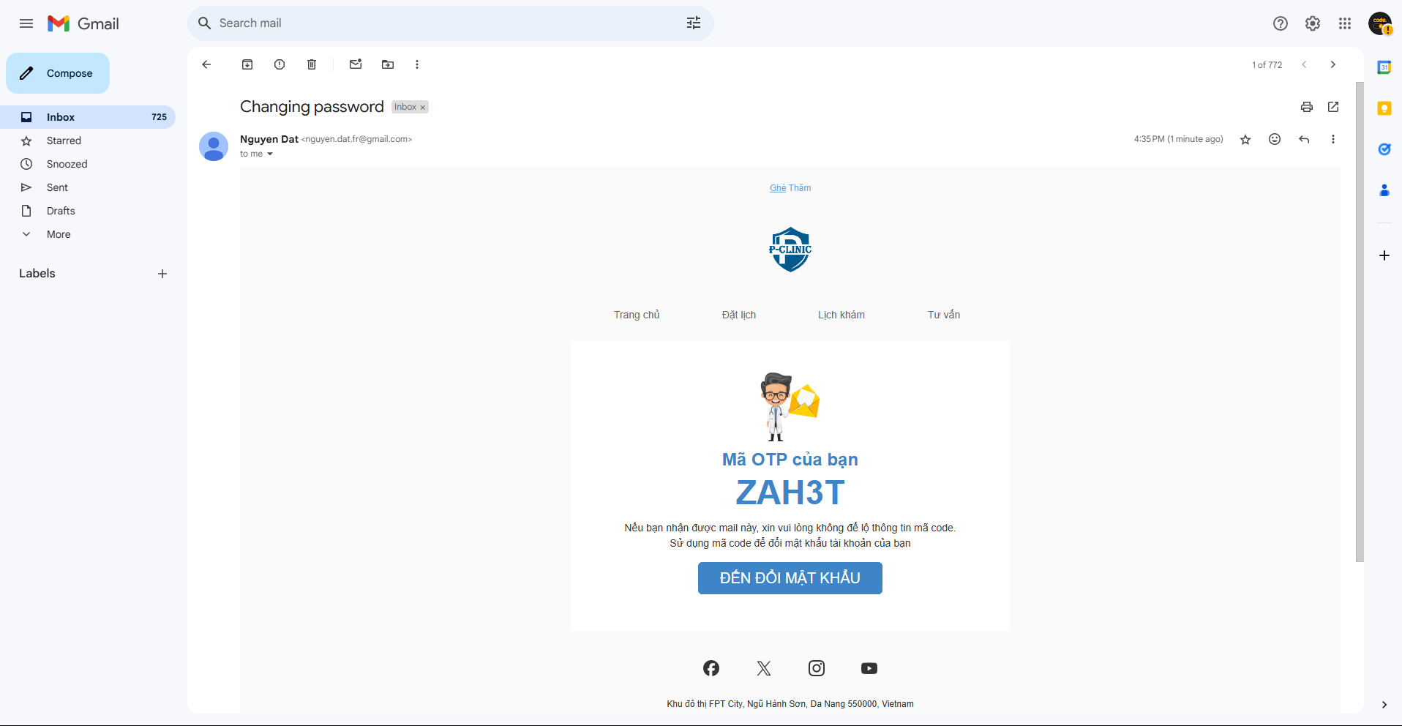

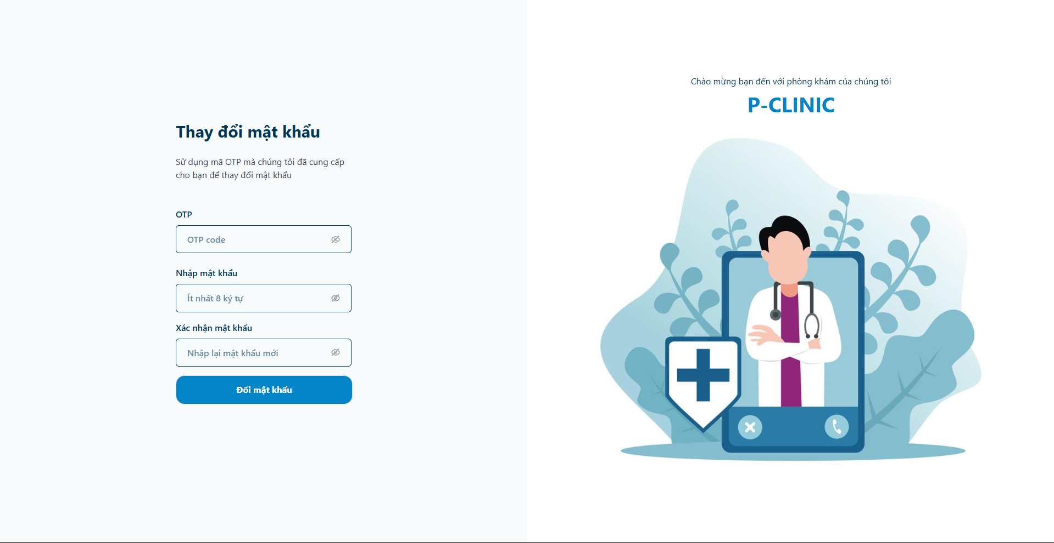

* Enter OTP code and new password

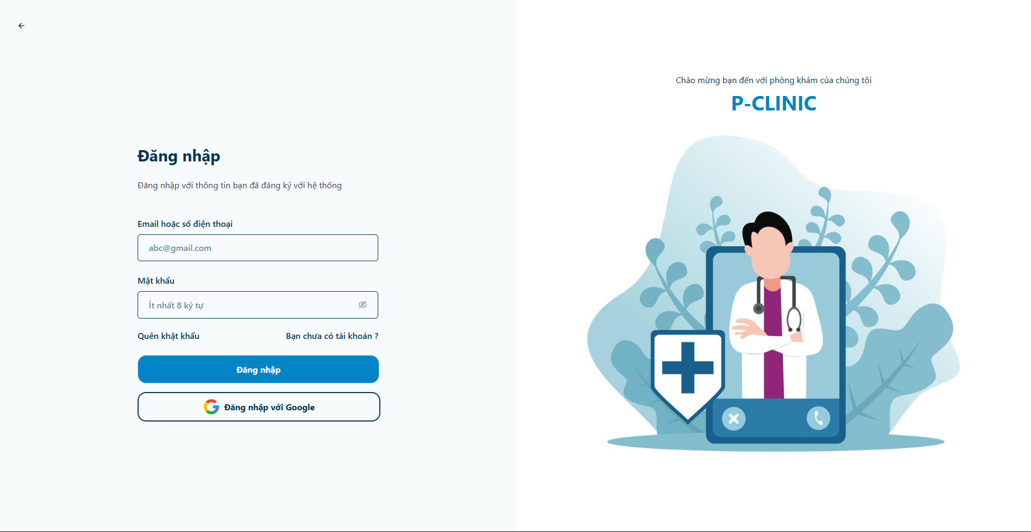

* Login after changed password success

## 5. Workflow - Send a contact

**Landing page screen**

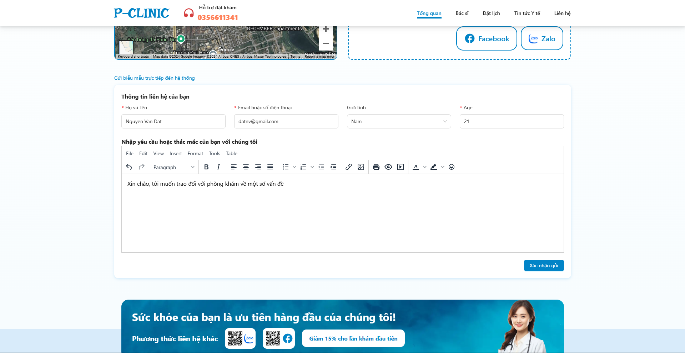

* User able to send a contact information to the clinic

**Admin screen**

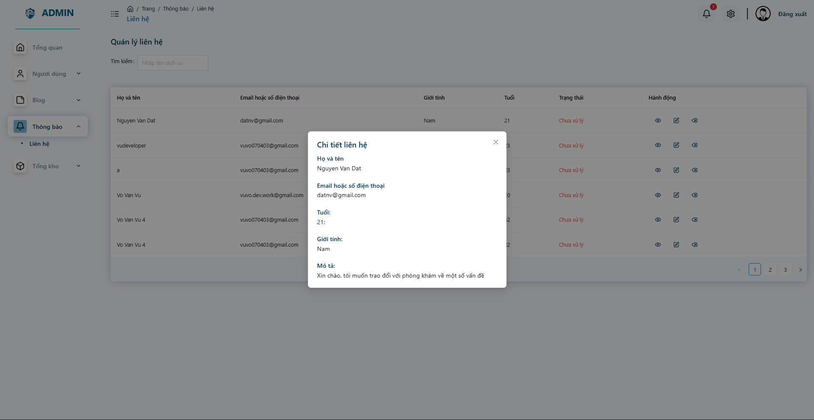

* Admin can follow and resolve the contact information

## 6. Workflow - Make an appointment

**Doctor screen**

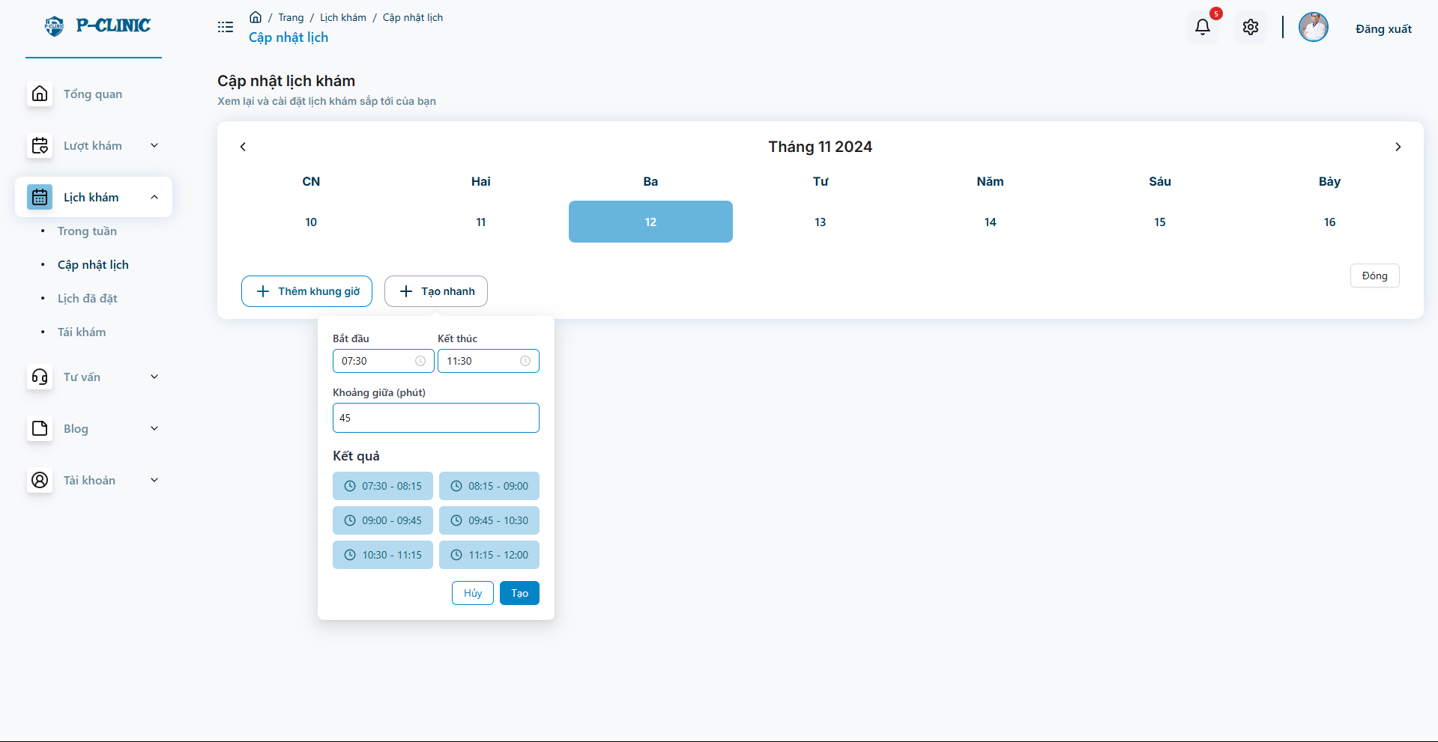

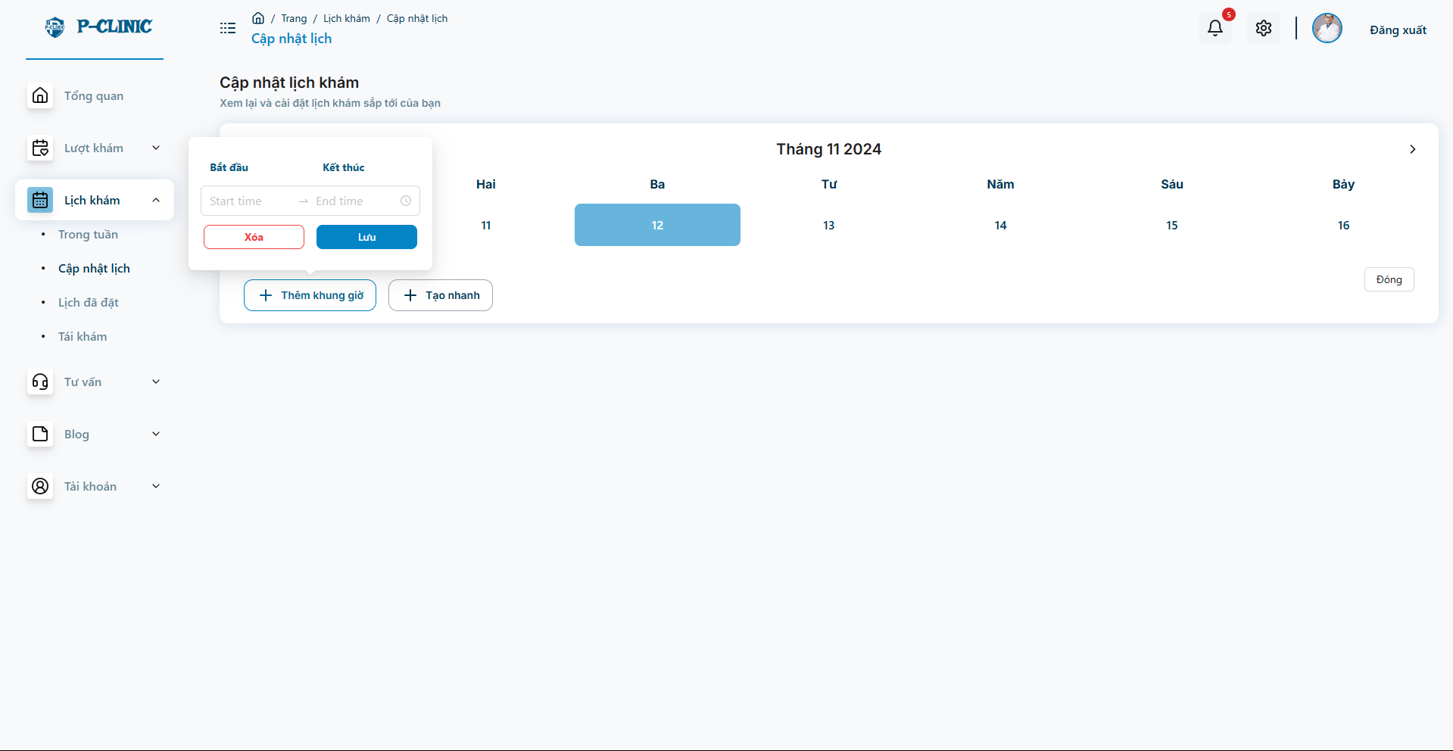

* Doctor update the treatment schedule with many slot on a day

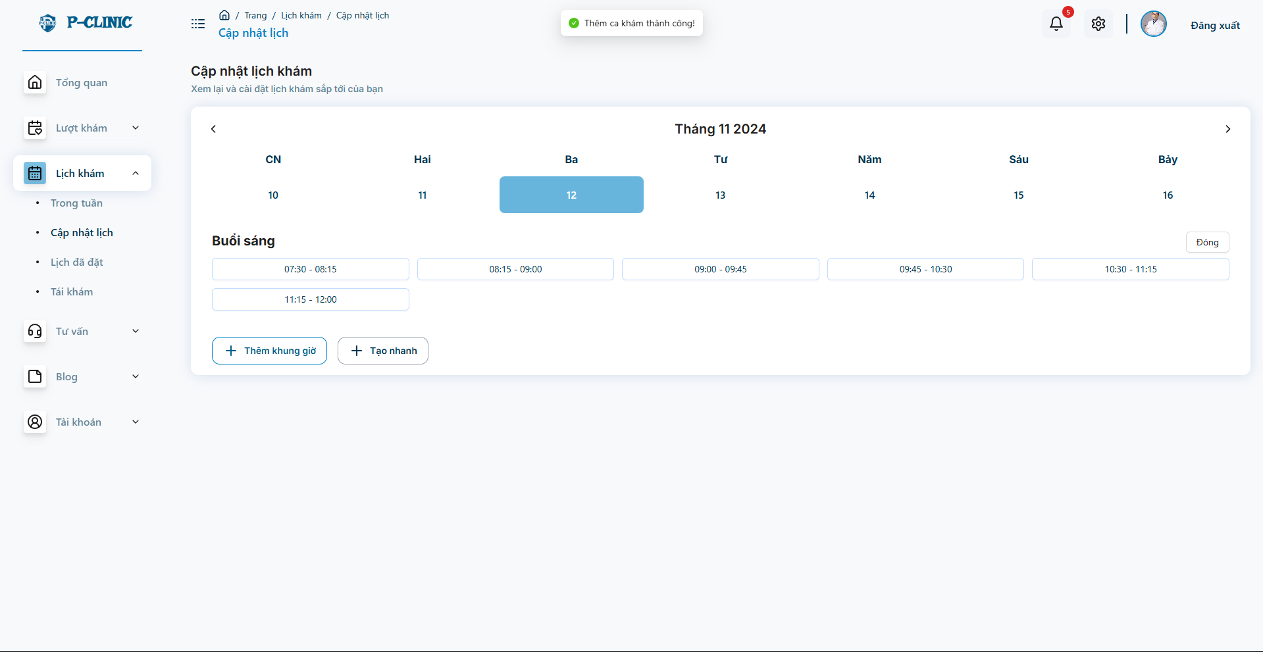

* Doctor create slots for treatment on a day successful

**User screen**

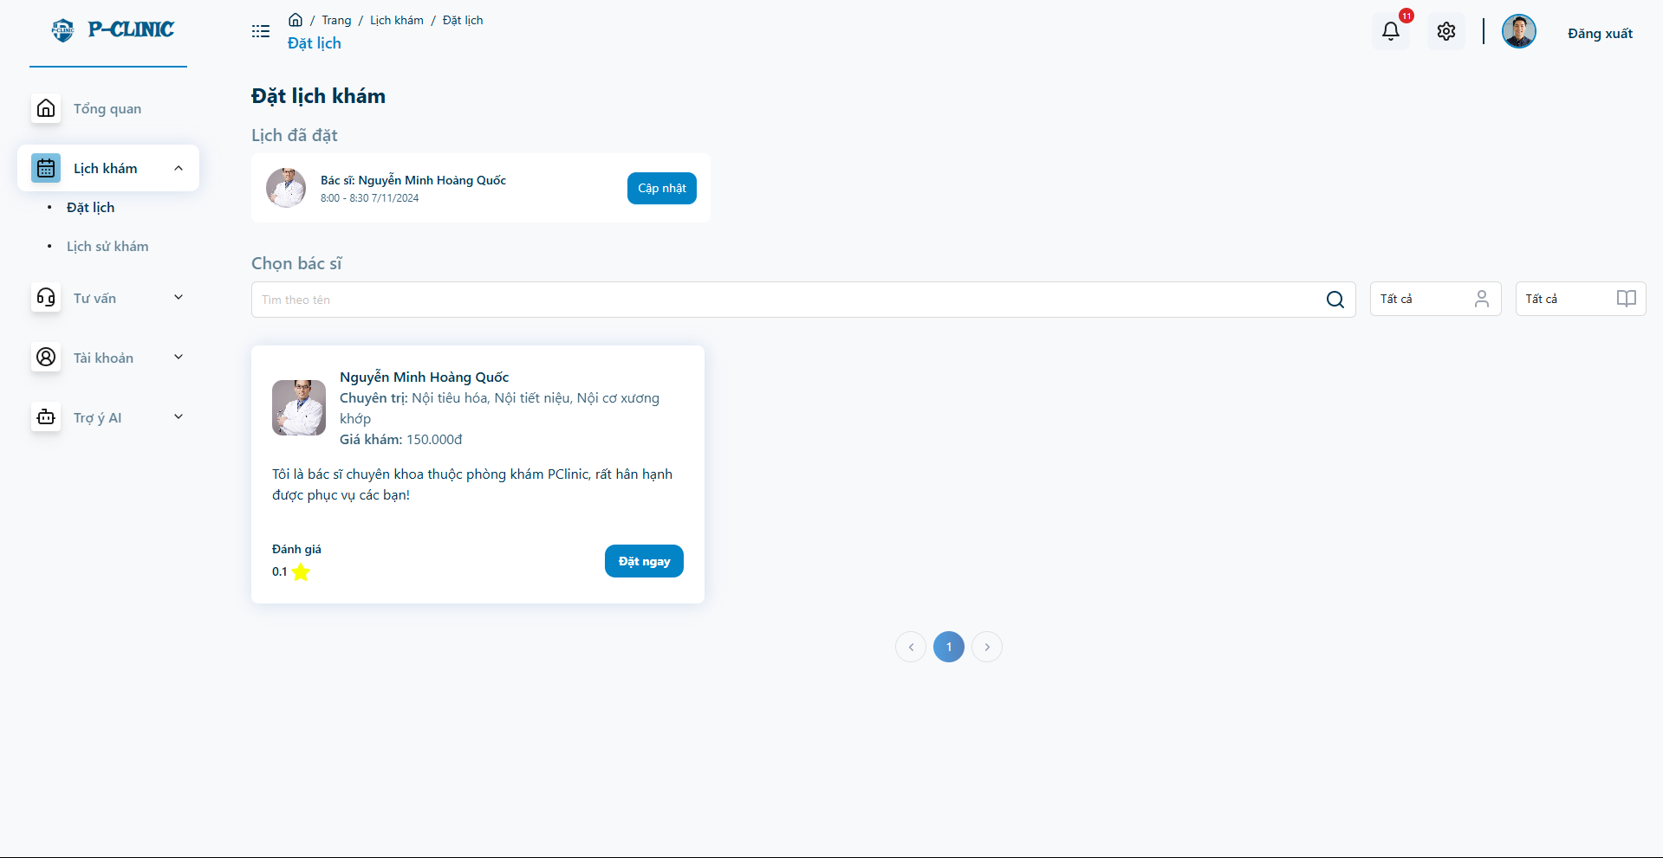

* User can view the booked appointment and choose the doctor to create new appointment for treatment

**User screen**

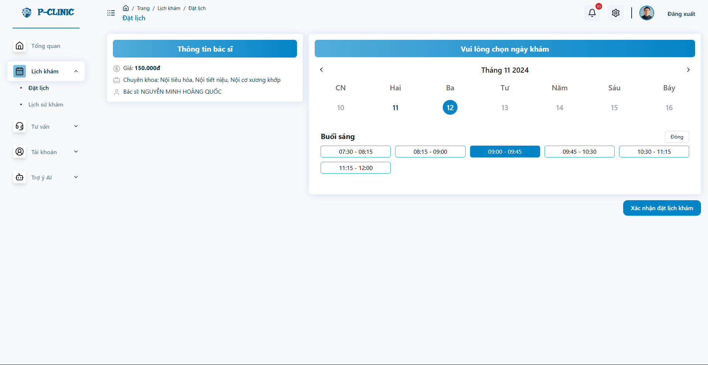

* After choose doctor, user can view and select the slots on the doctor’s schedule

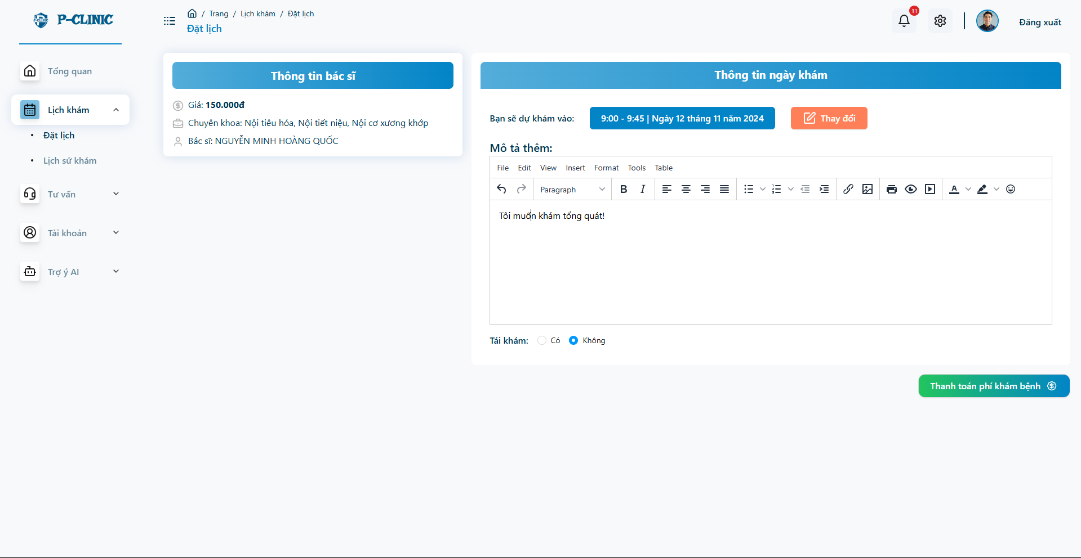

* After choosing a slot and doctor, User needs to confirm the appointment before paying.

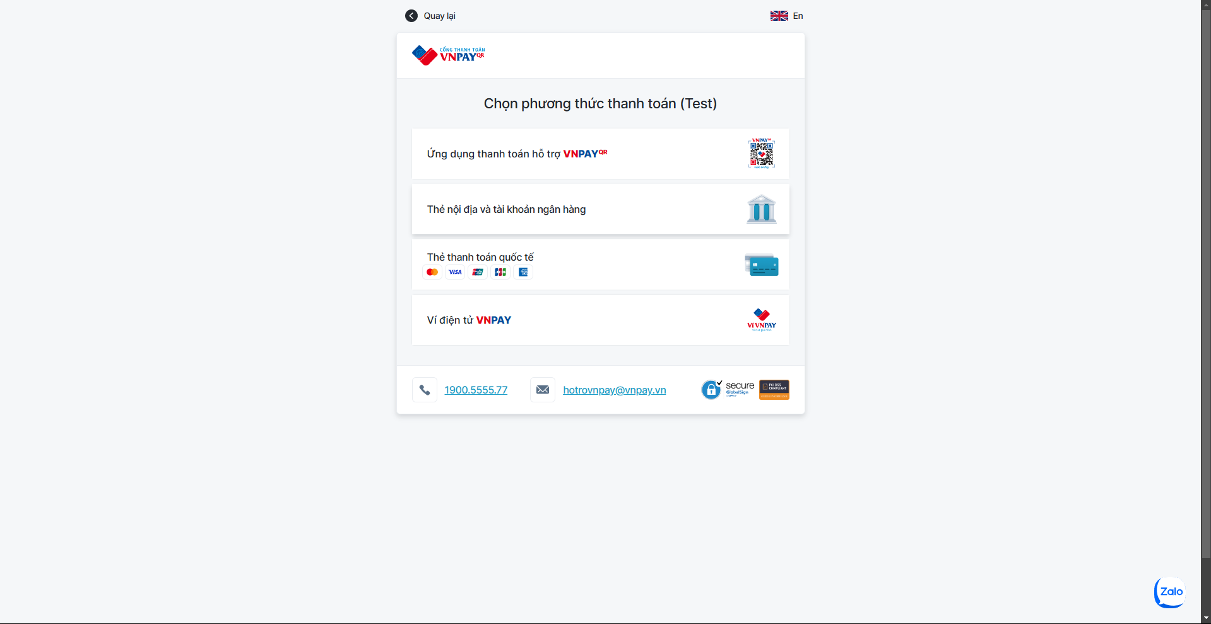

* Processing payment with VNPay

**User screen**

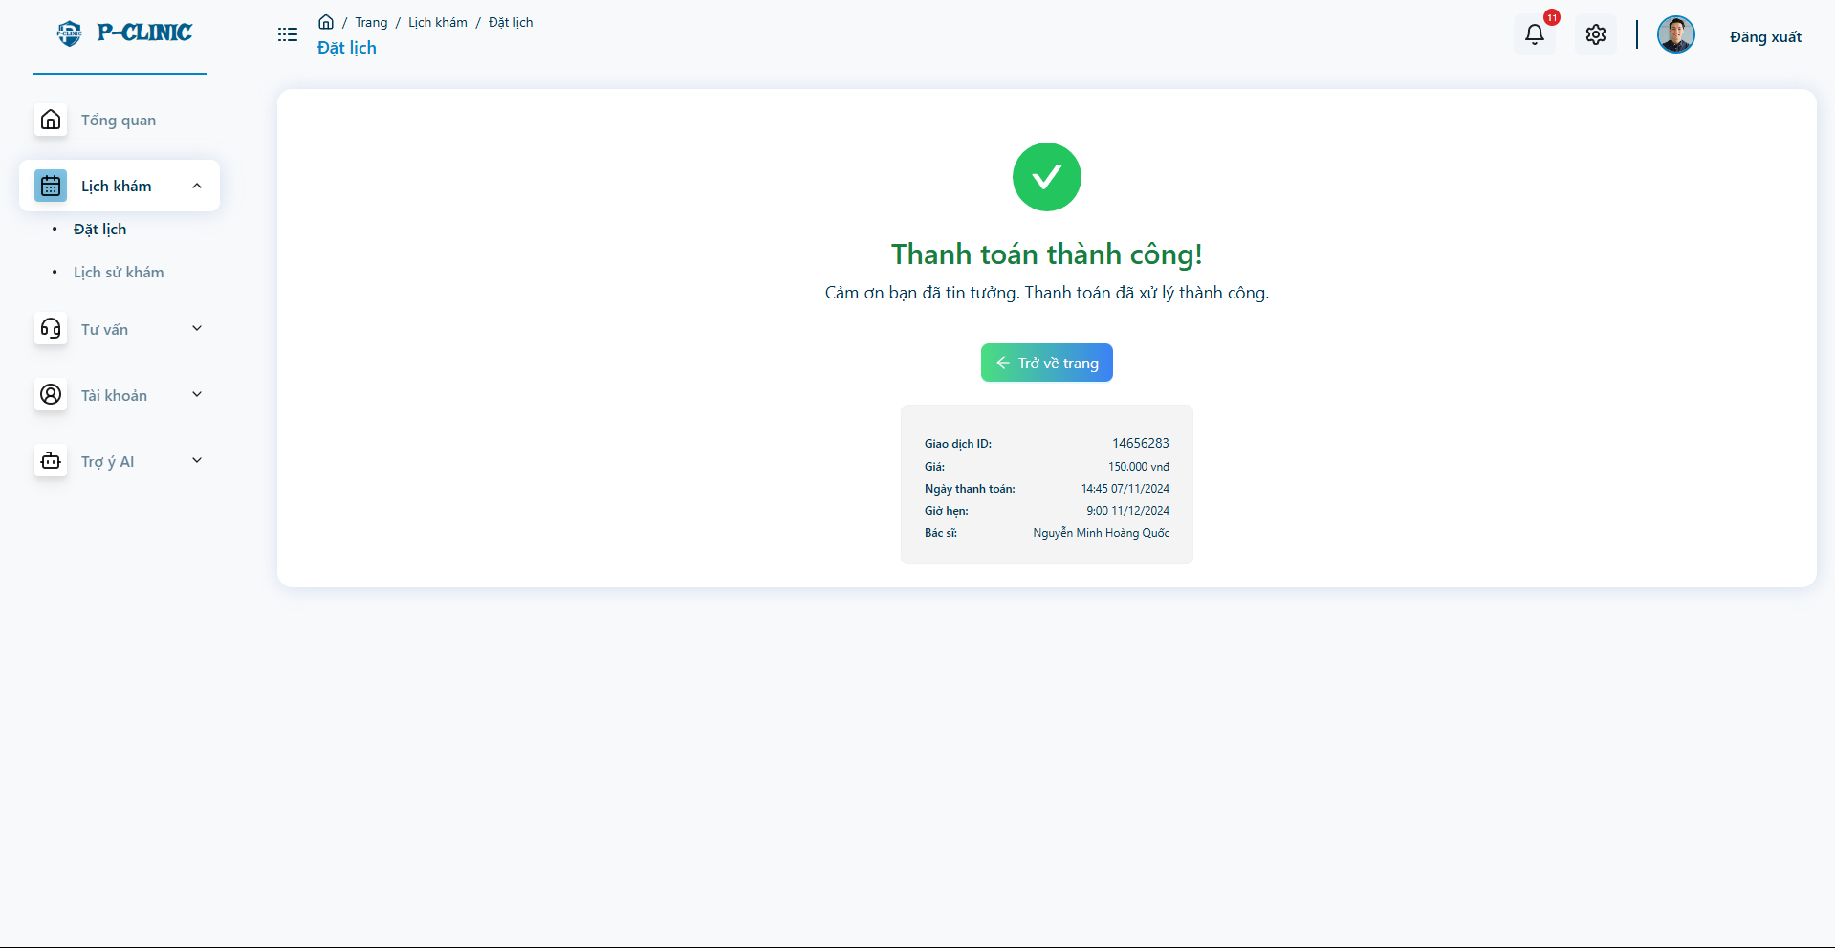

* After payment successful

**Doctor Screen**

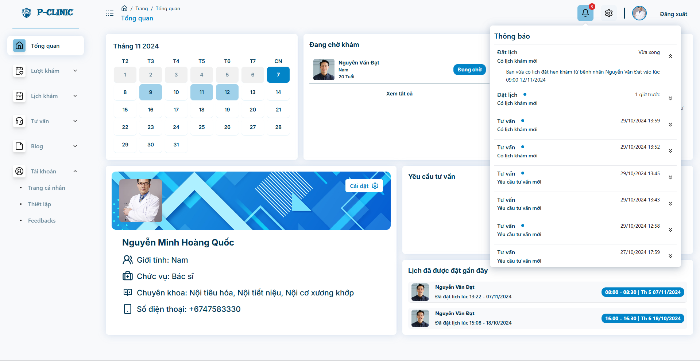

* Doctor received a notification about a new appointment coming!

**User screen**

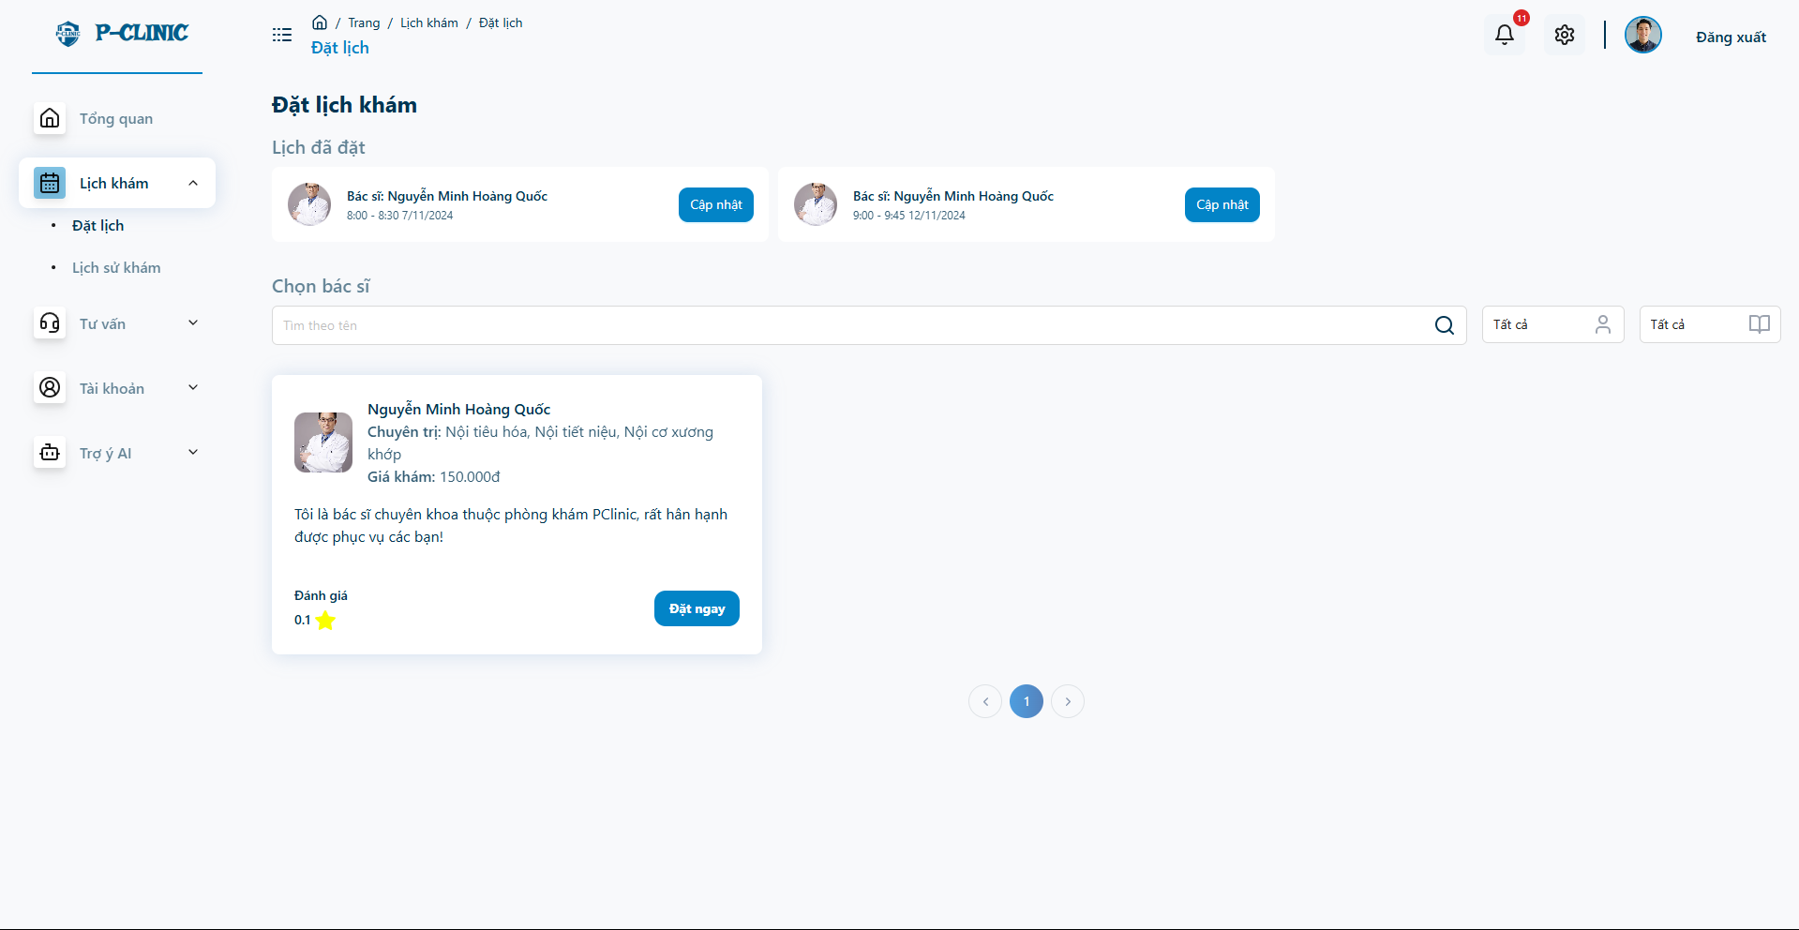

* User can follow the appointment information for treatment

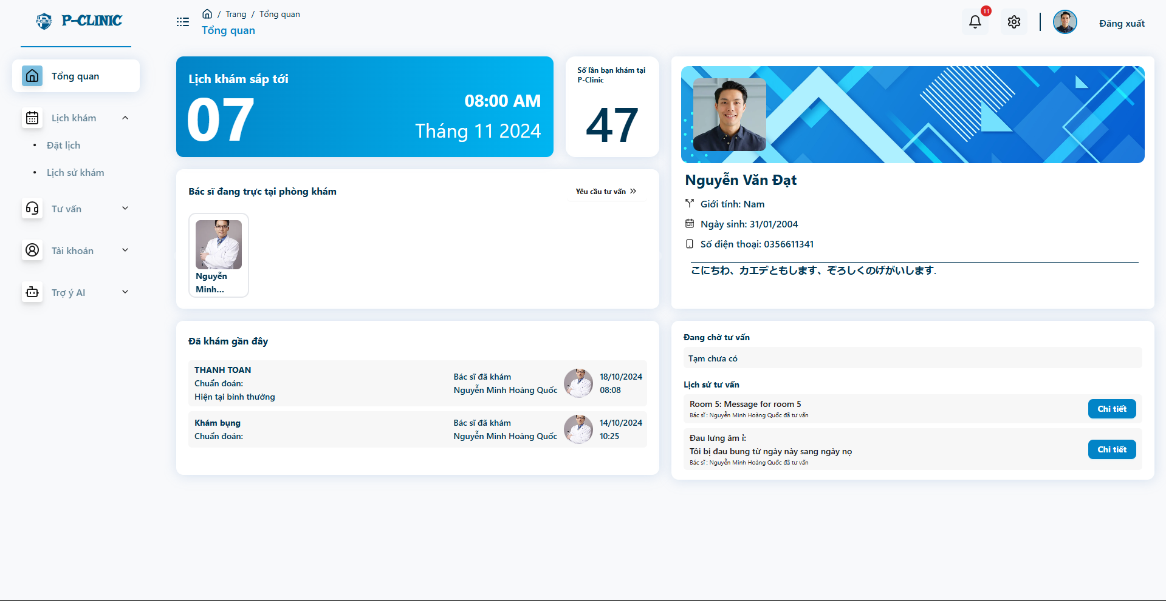

* User also follow the appointments and other information from this overview screen

## 7. Workflow - Make online consultant

**User screen**

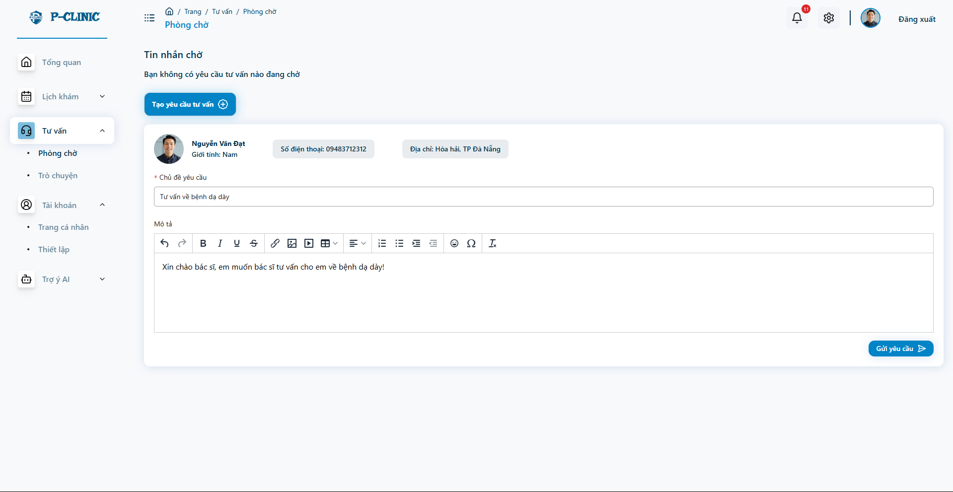

* User send a consultant request to the clinic

**User screen**

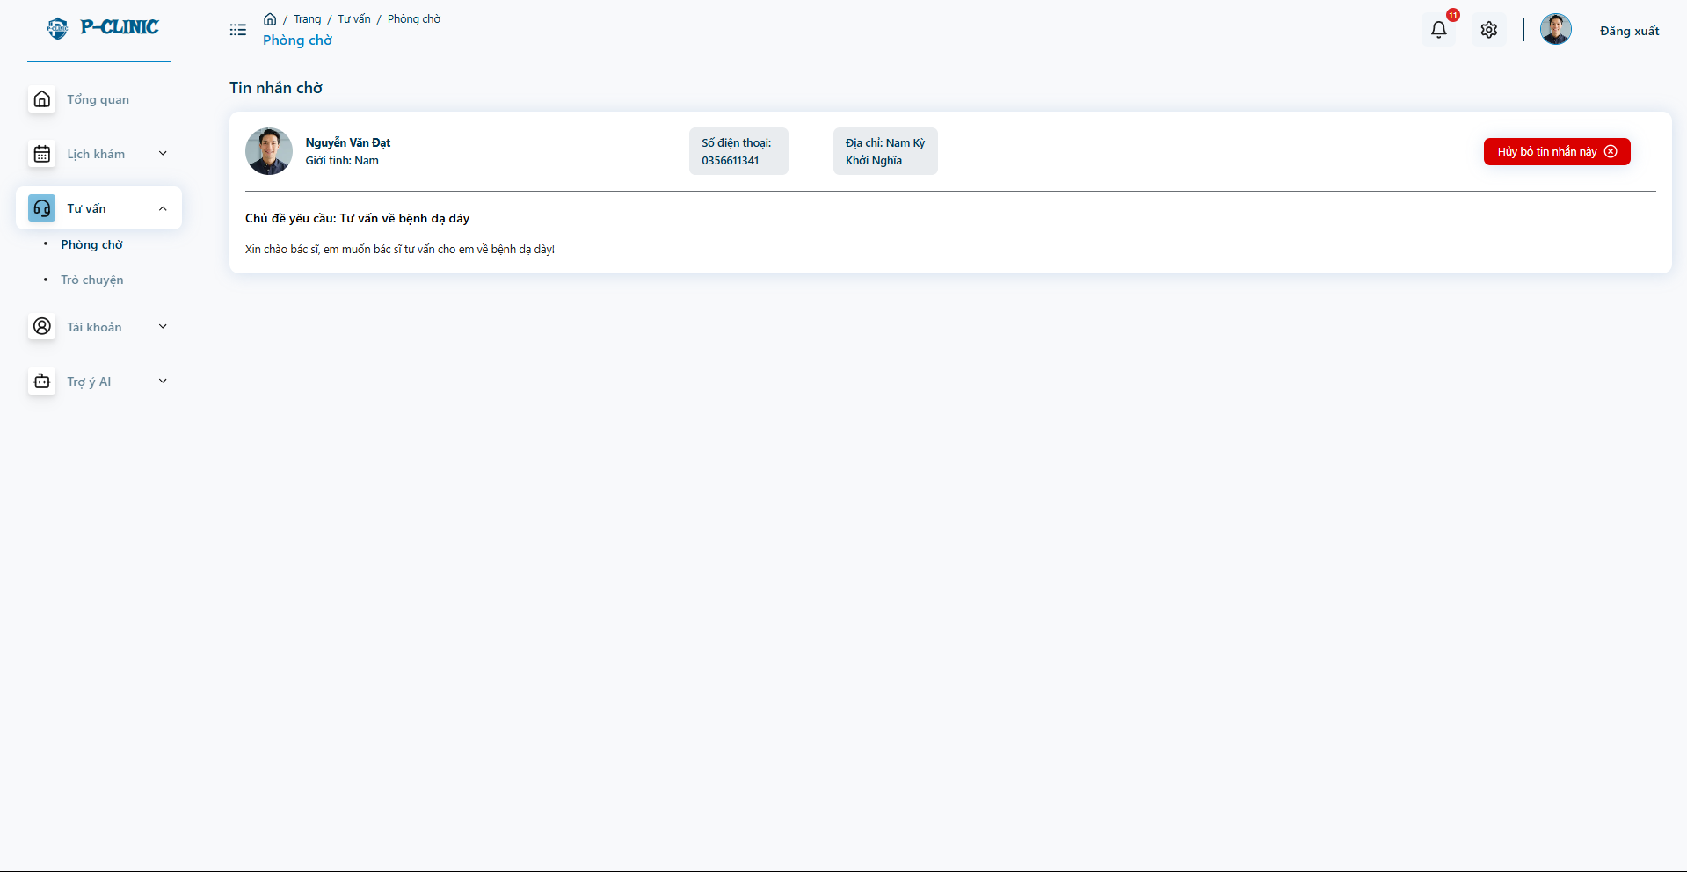

* User can review the request and able to cancel it

**Doctor screen**

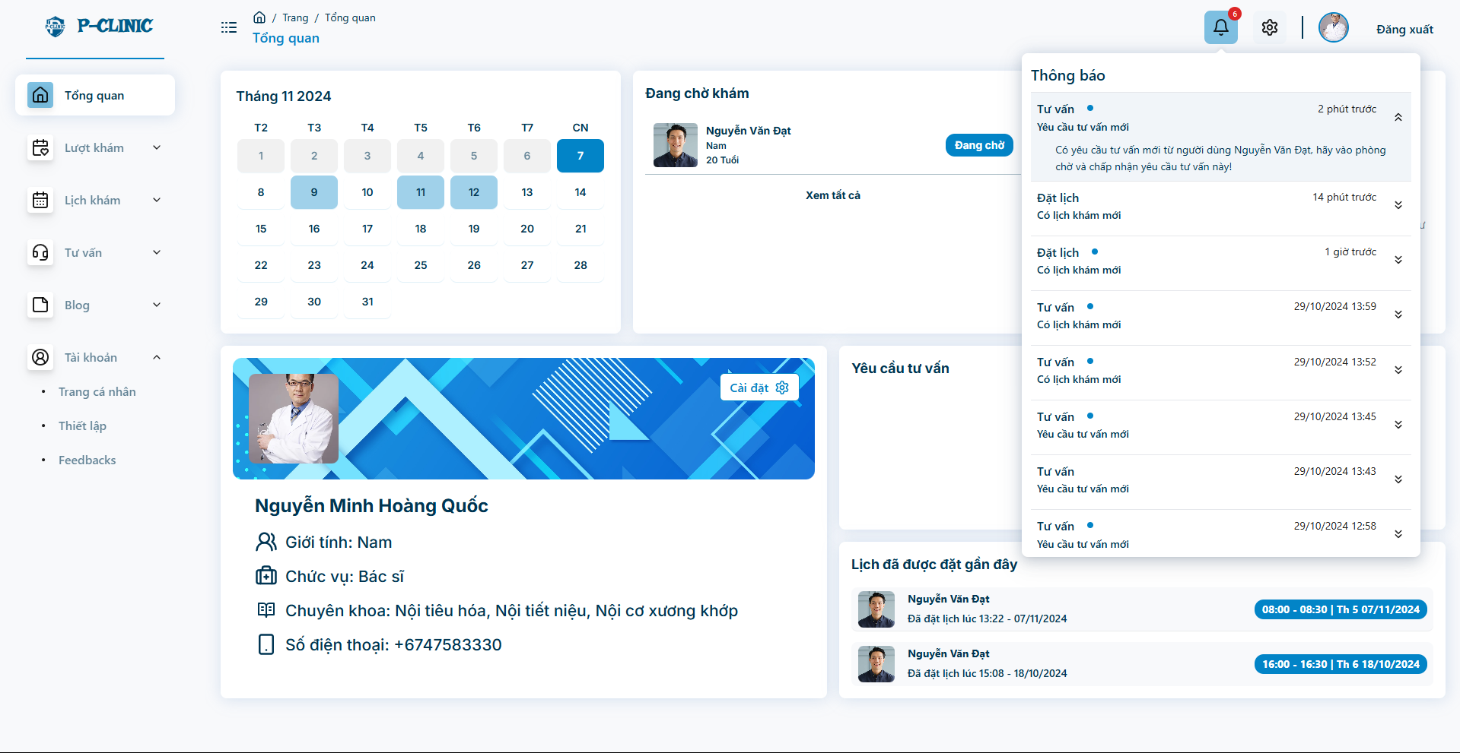

* Doctor received the new notification about new consult request

**Doctor screen**

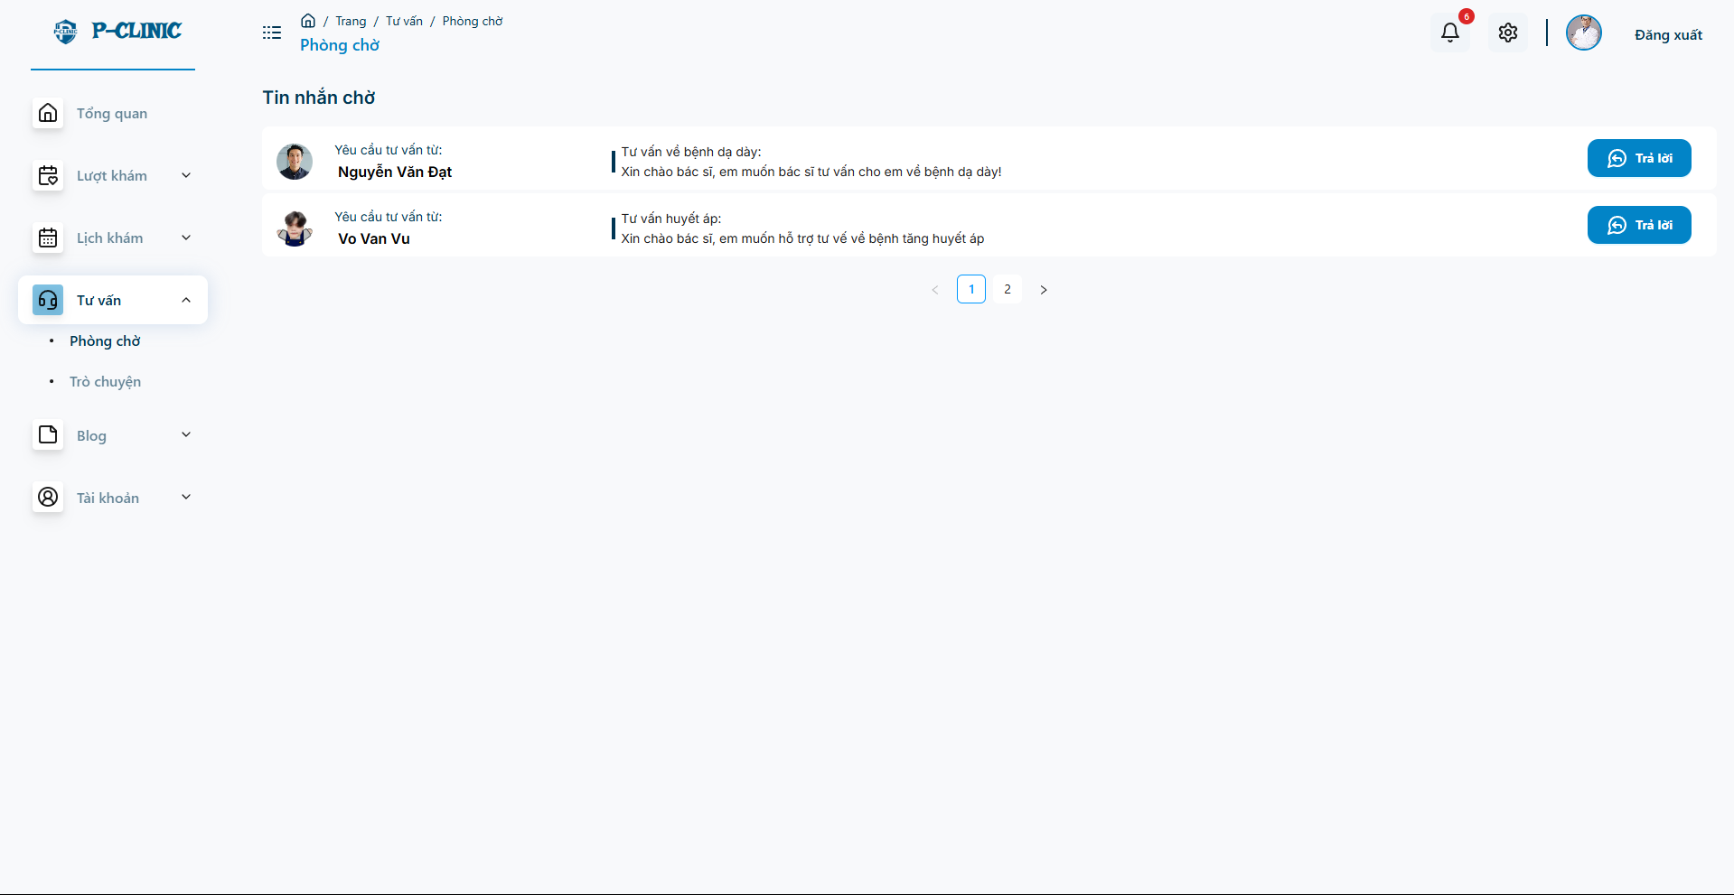

* Doctor can view all the consult request and reply from pending room

**Doctor screen**

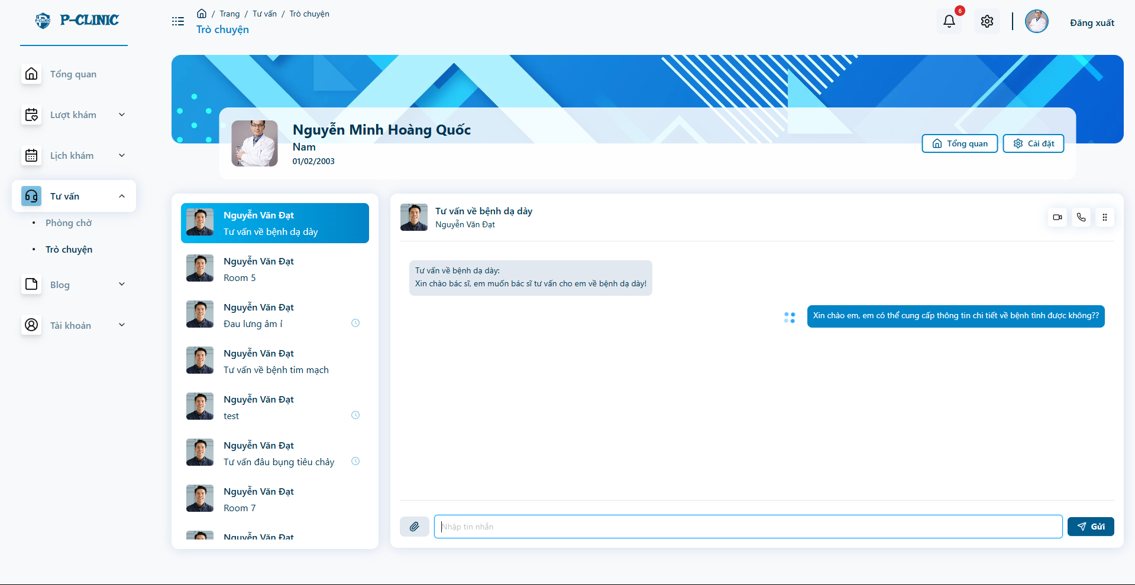

* After reply from pending room, doctor and user can start the conversation

**User screen**

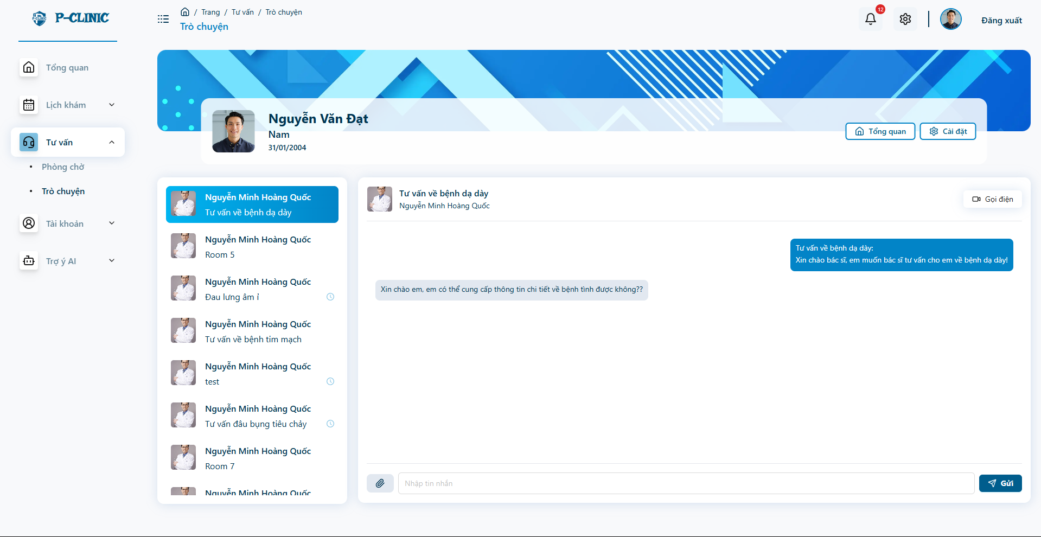

**Doctor screen:**

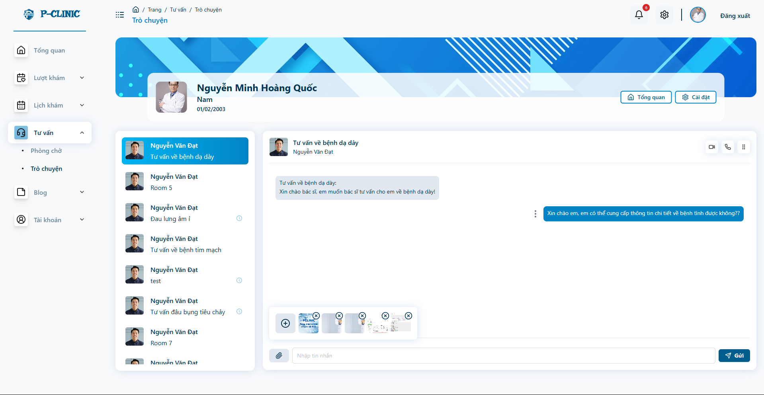

* Able to send multiple file

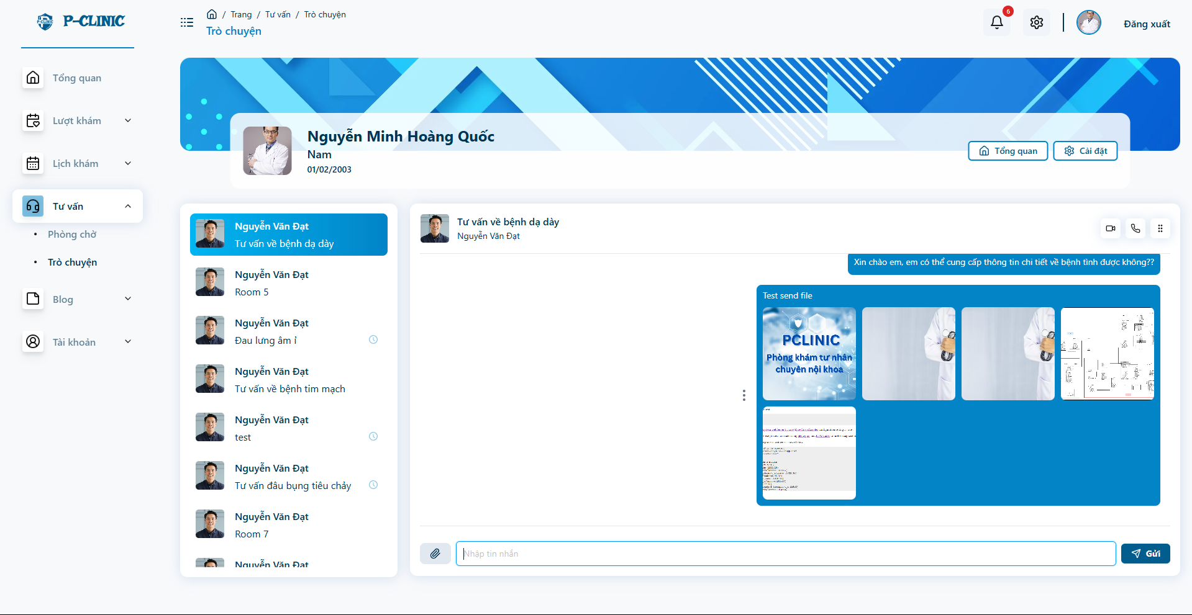

* After send multiple file

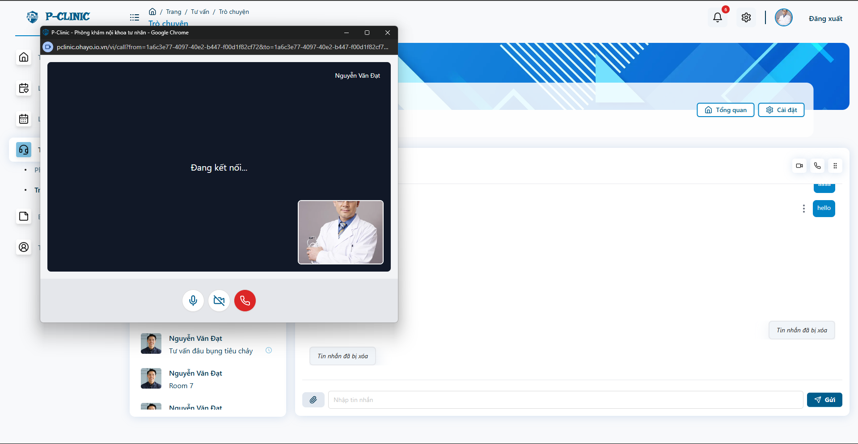

* Doctor able to make an video call with the patient

**User screen:**

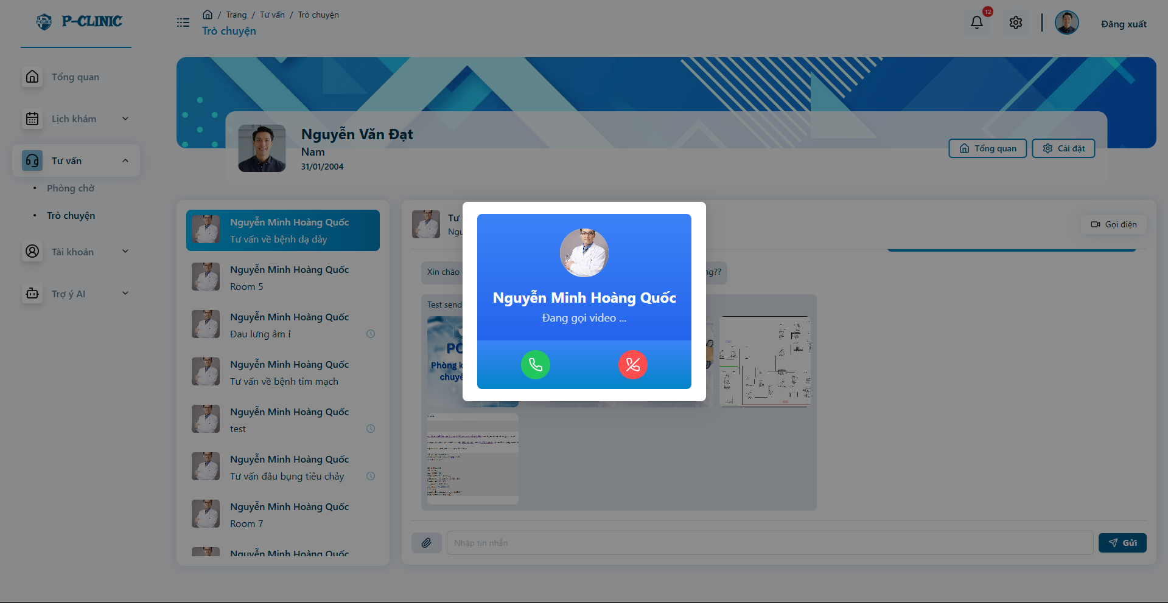

* Users can view the showing of new calls from the clinic by the noise of the notified sound effect.

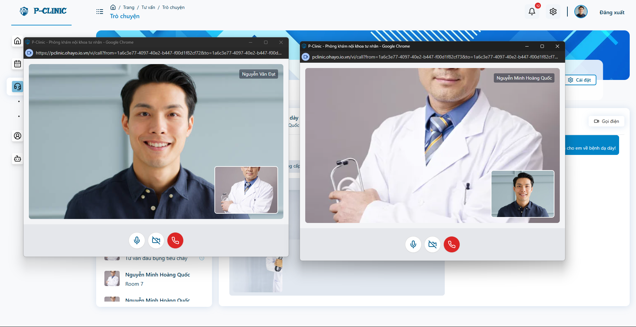

* After pickup the call

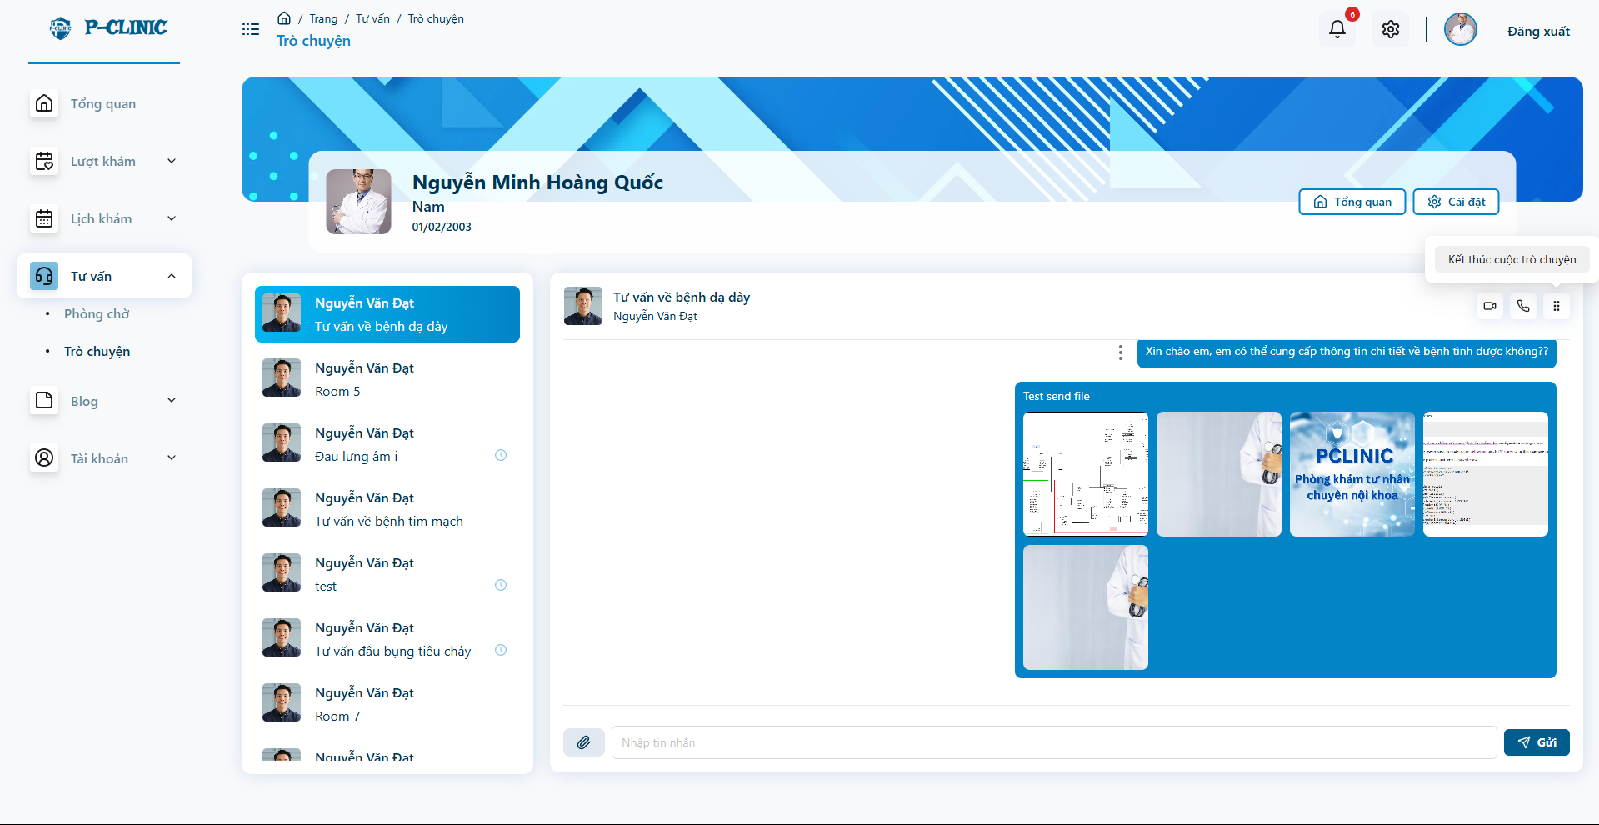

* Doctor able to end the conversation

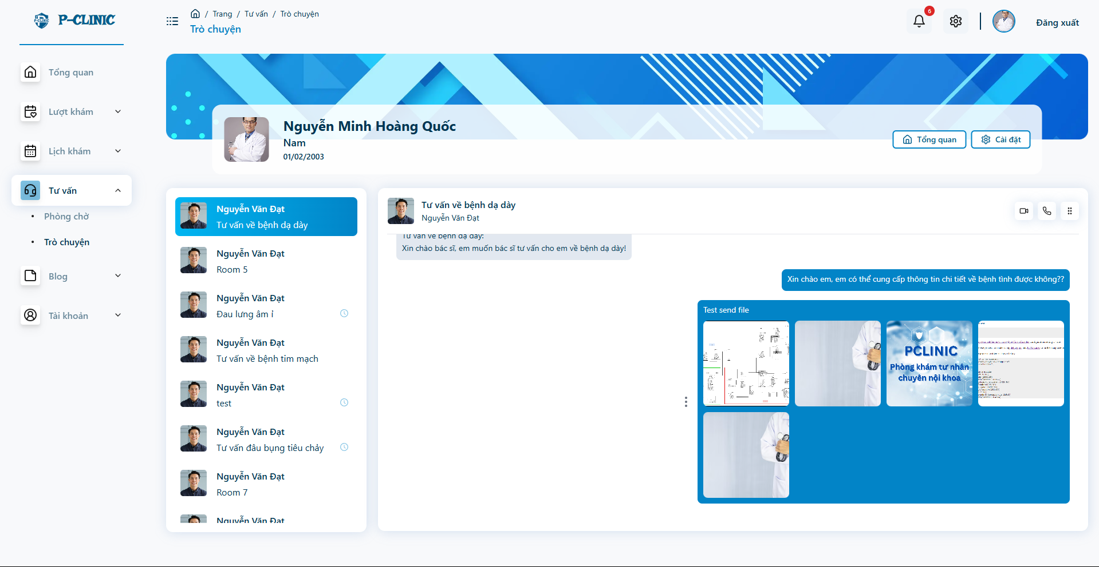

* After end conversation, can't continue messaging

**User screen**

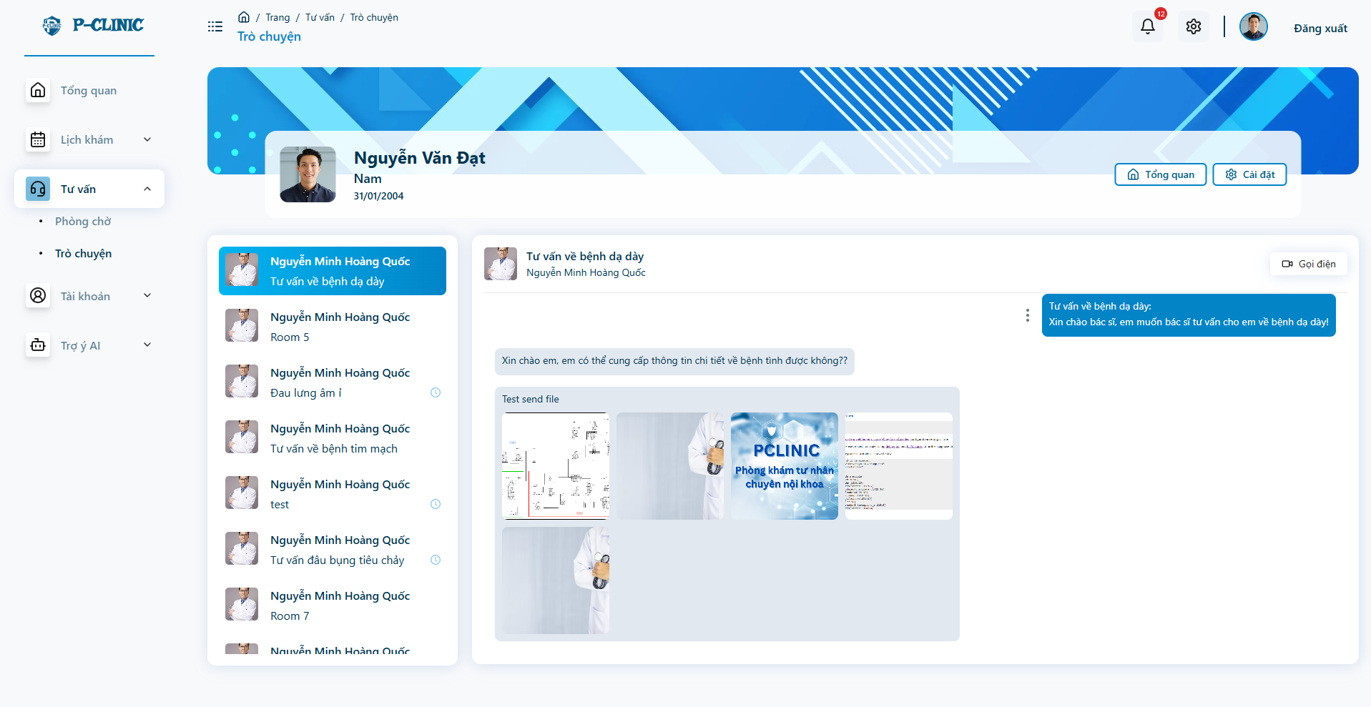

## 8. Workflow - Treatment and medical report

**Doctor Screen**

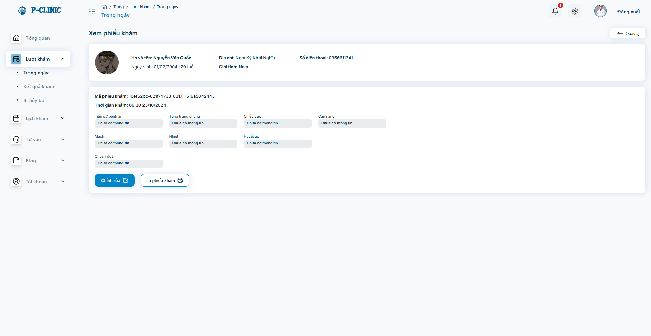

* **Doctor can view the create and view medical report information**

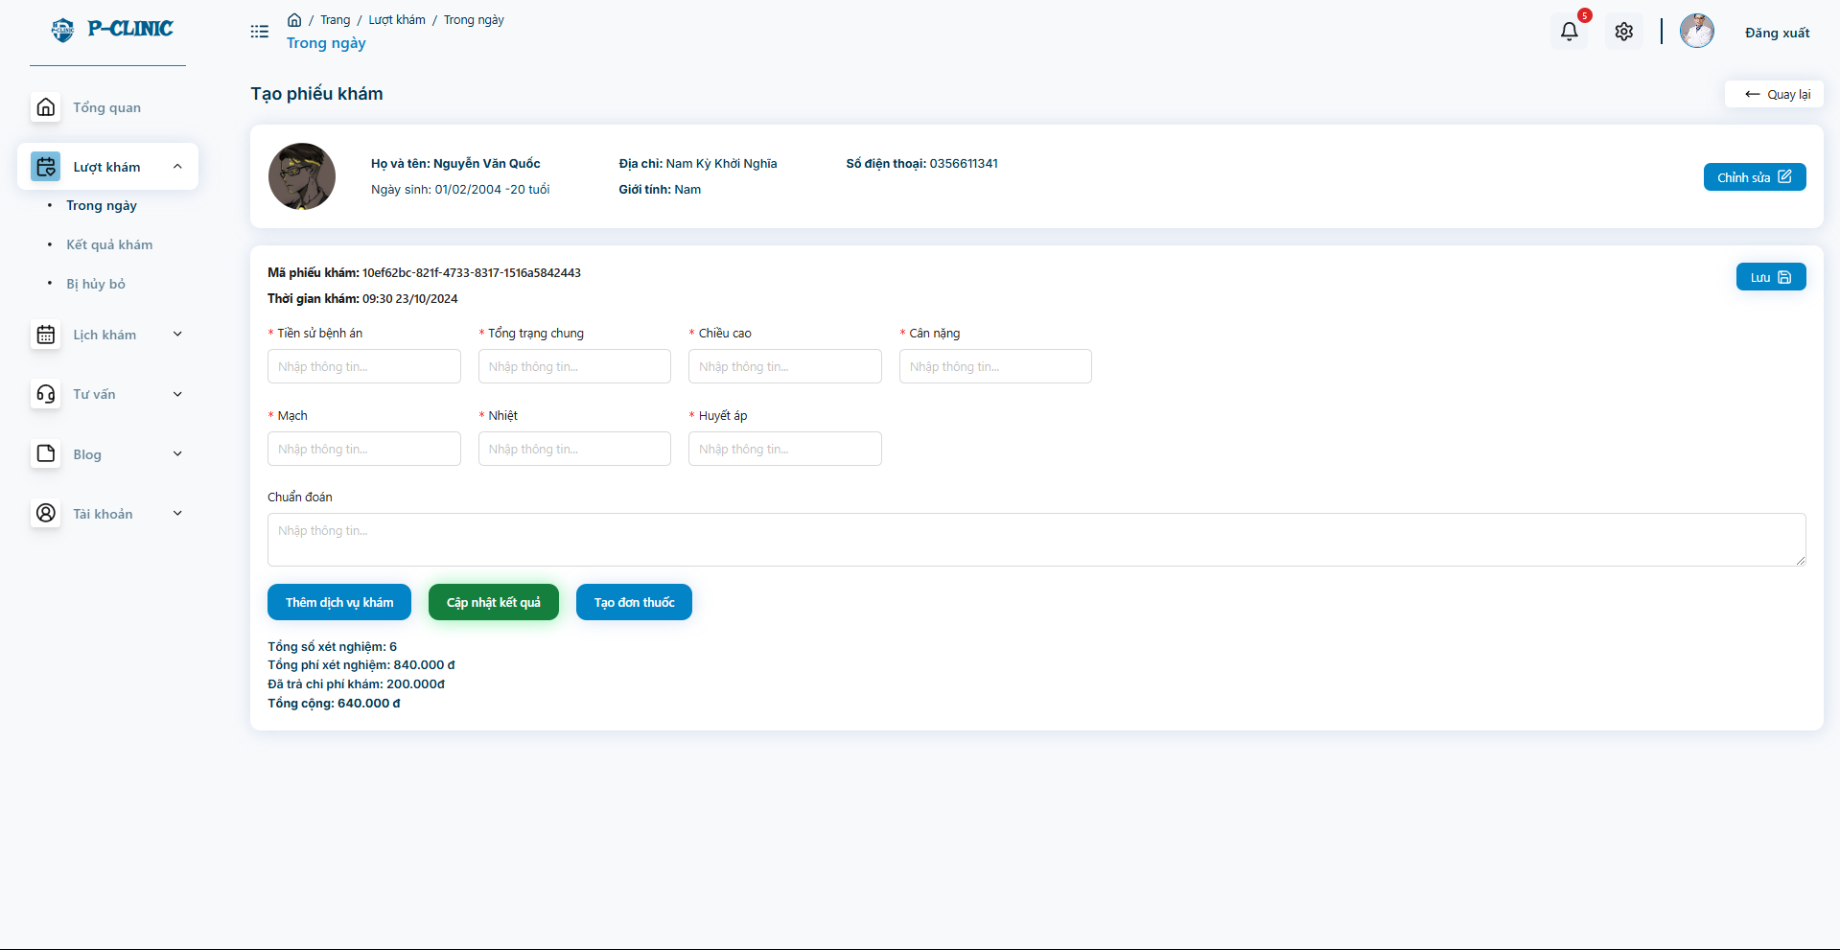

* **Doctor update the information of the medical report**

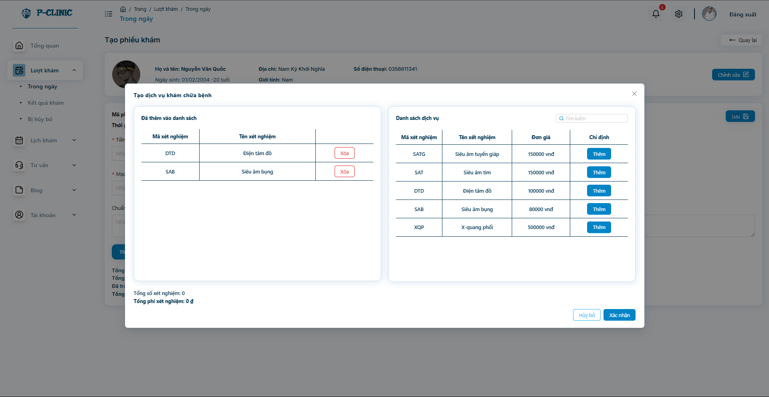

* **Doctor update the medical services for the treatment turn**

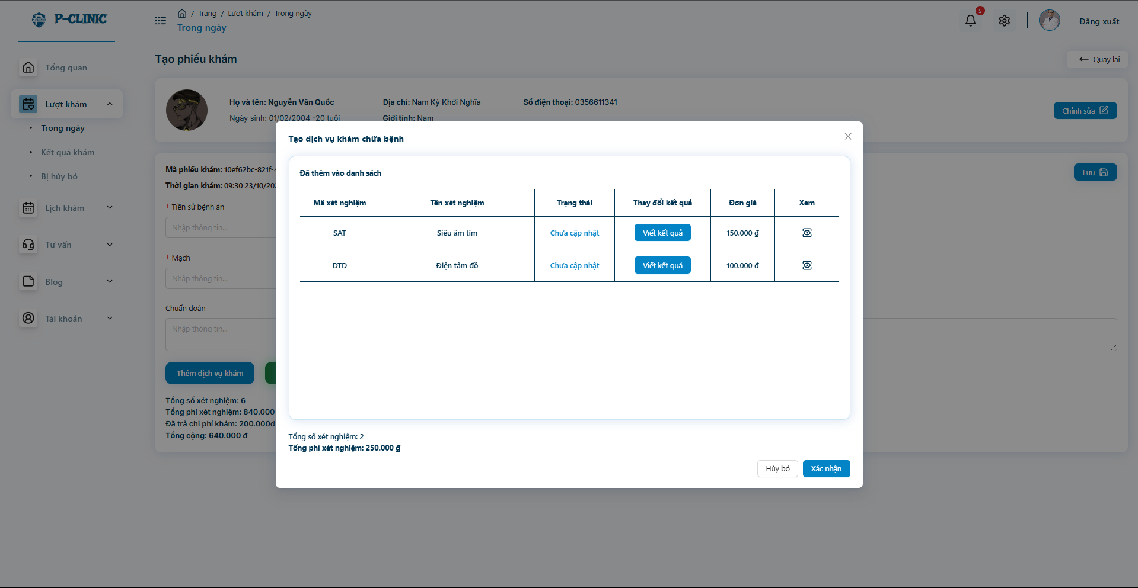

* **Doctor able to create and update the information of the services after success testing**

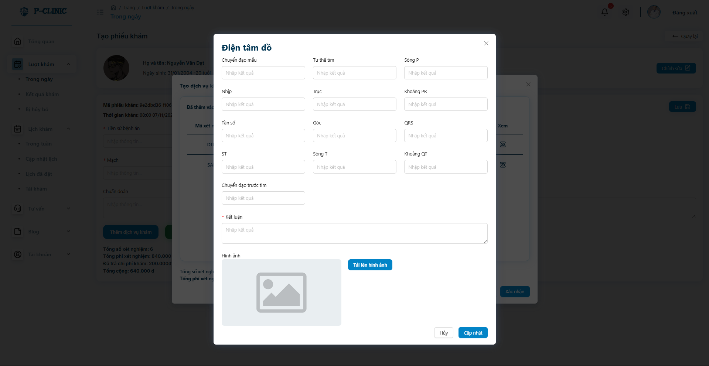

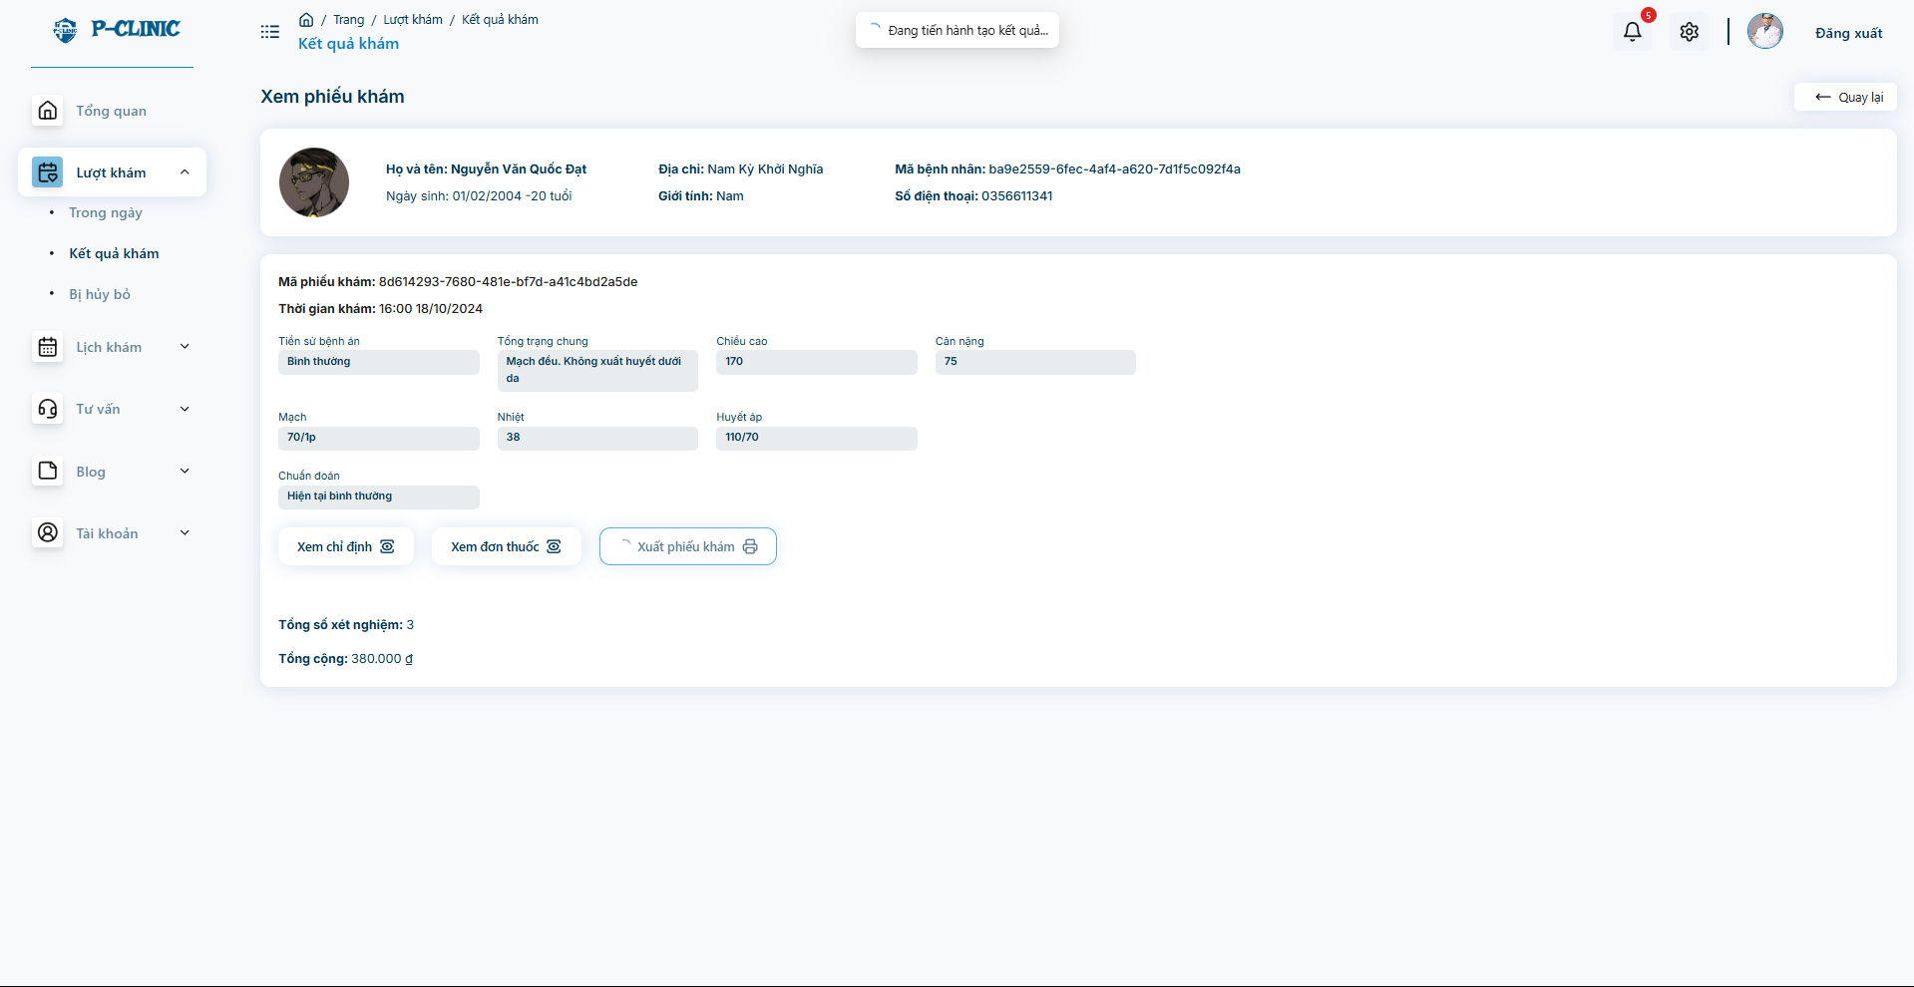

* **Doctor or Staff able to export the document of the medical report and print it**

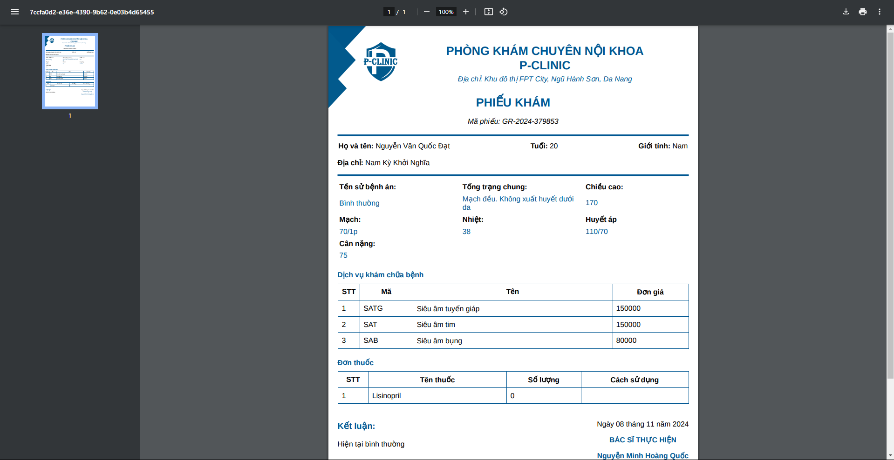

* **Example**

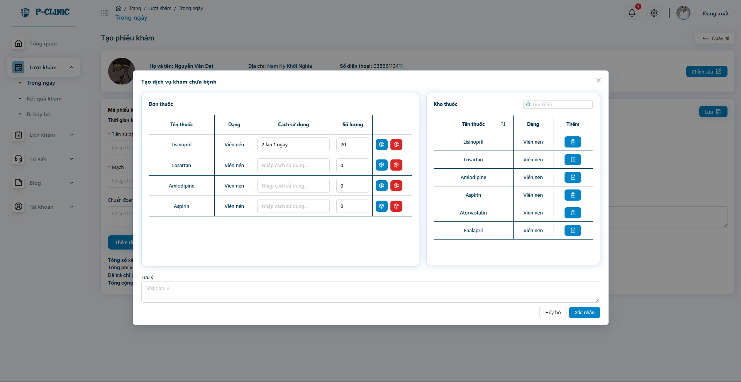

* **Doctor can create medicines for patient can order**

## 9. Workflow - Treatment history

**User screen**

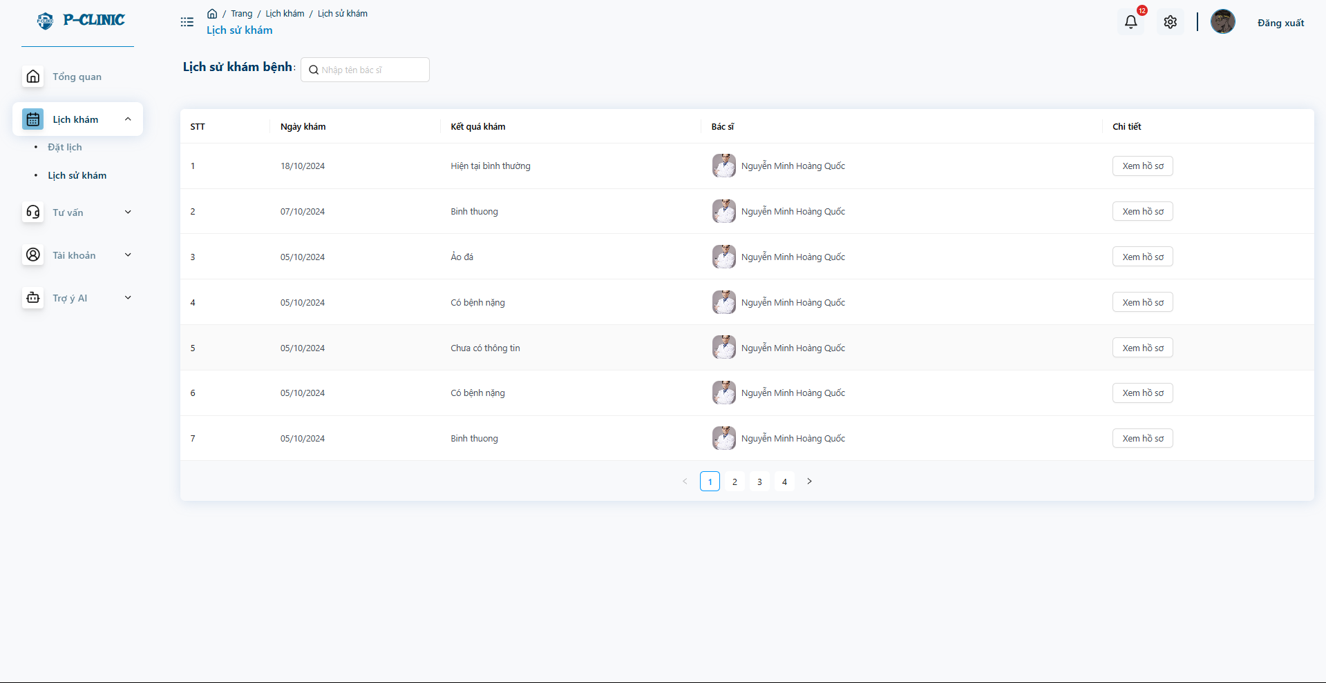

* **User can view list of medical report histories**

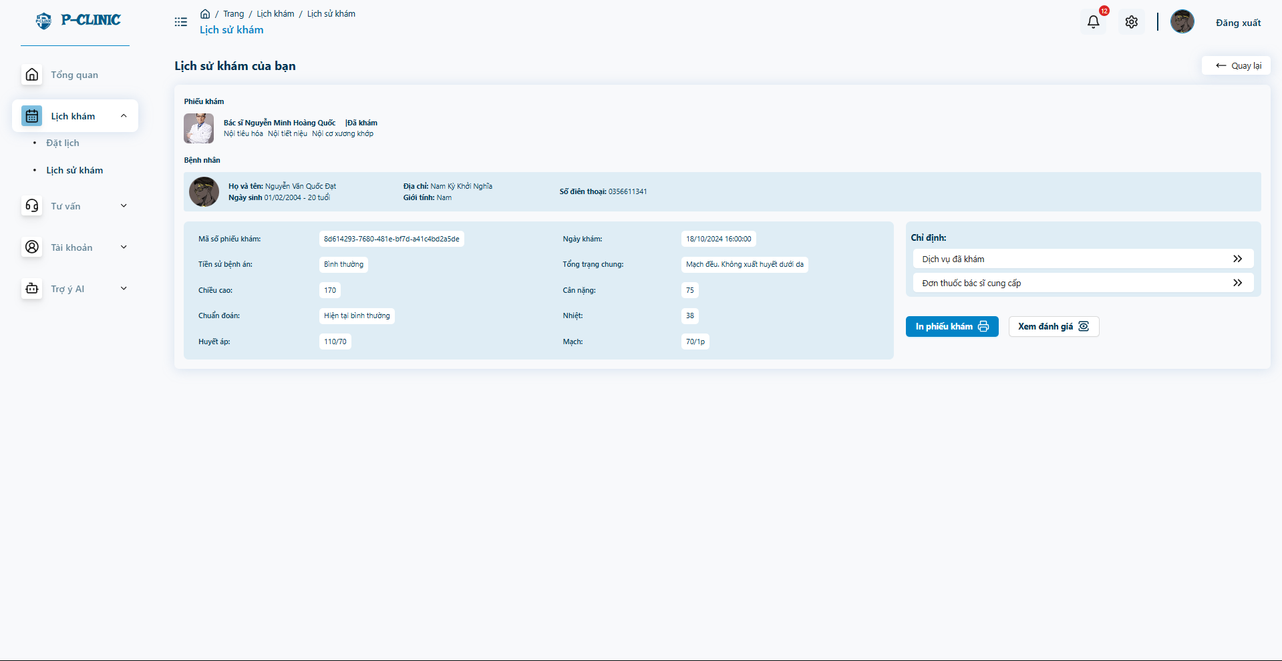

* **Detail in history medical report**

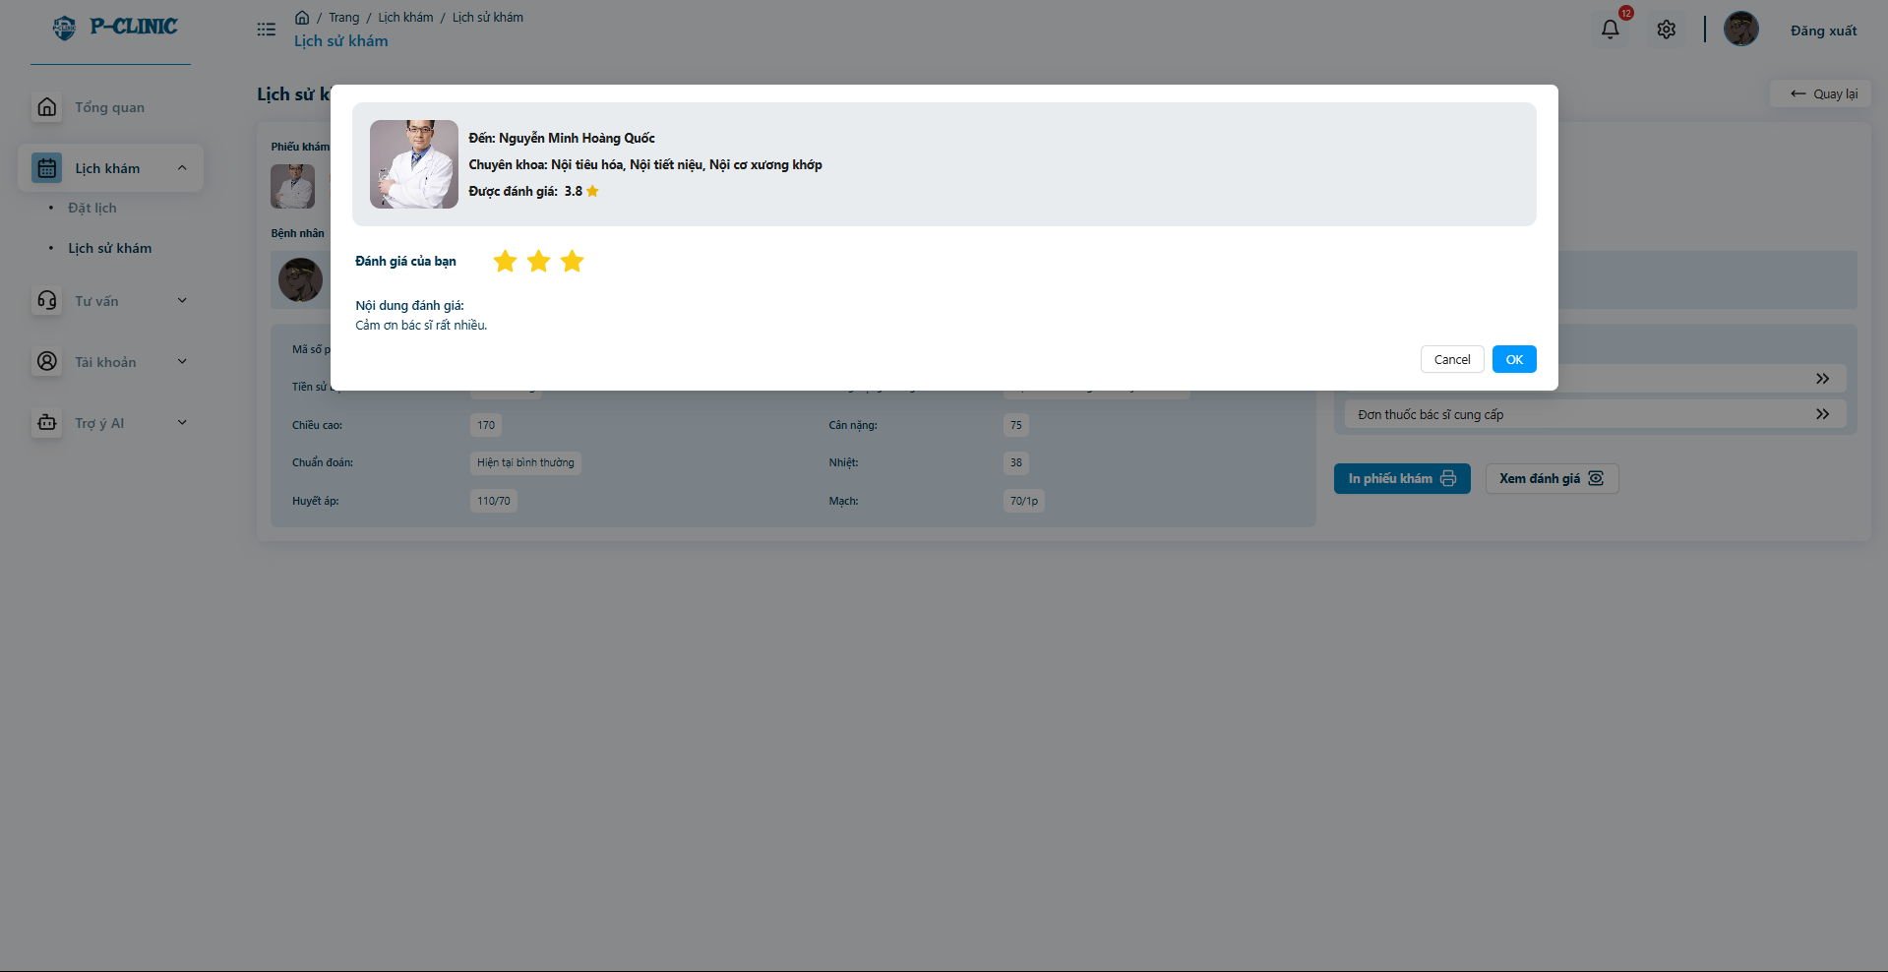

* **User able to send a feedback and review it**

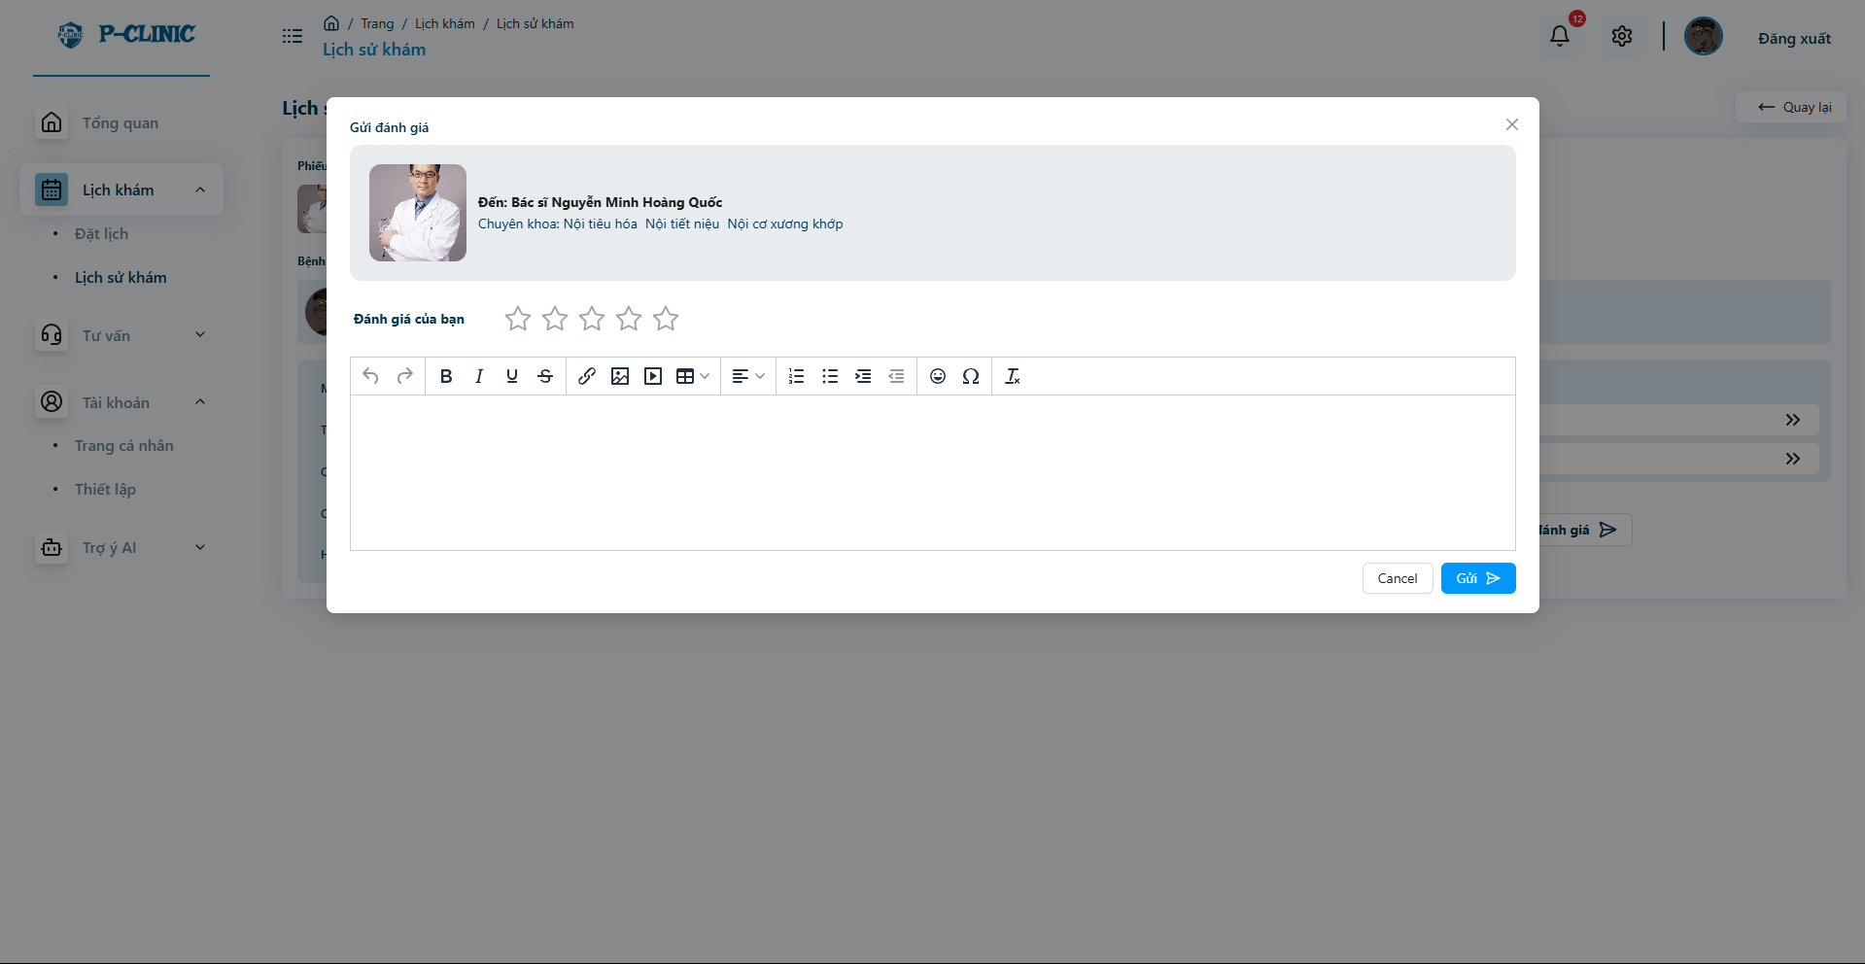

## 10. Workflow - Manage warehouse

**Admin screen**

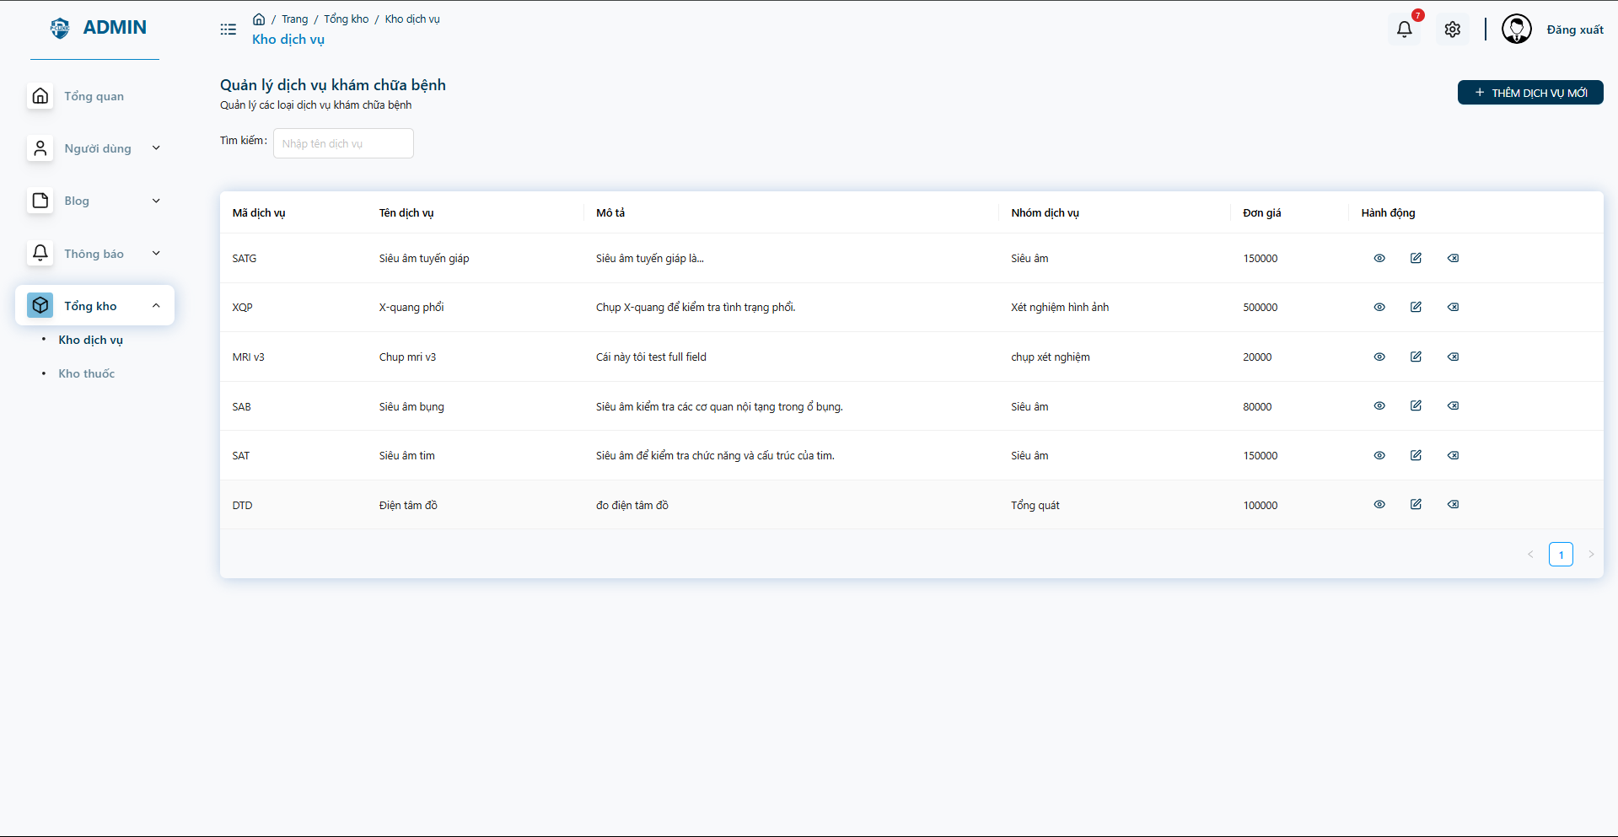

* Admin can manage the medical service of the clinic

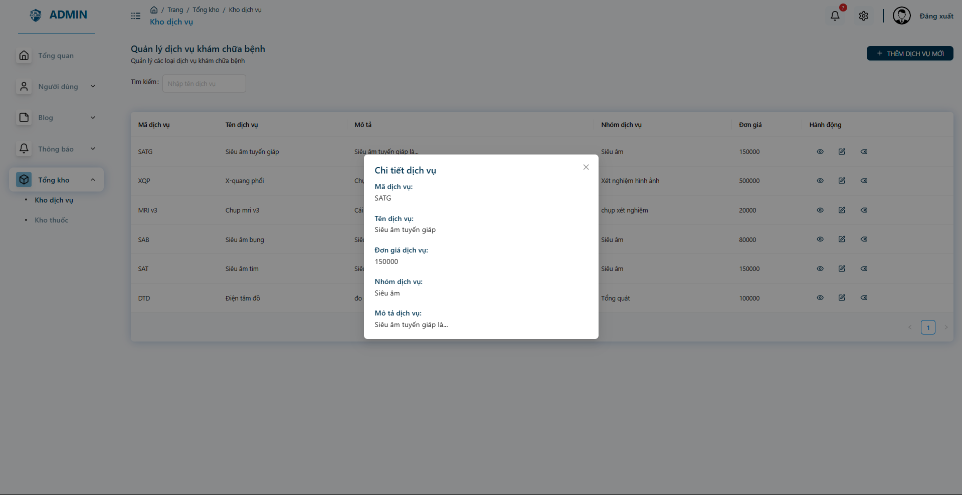

* Services information in detail

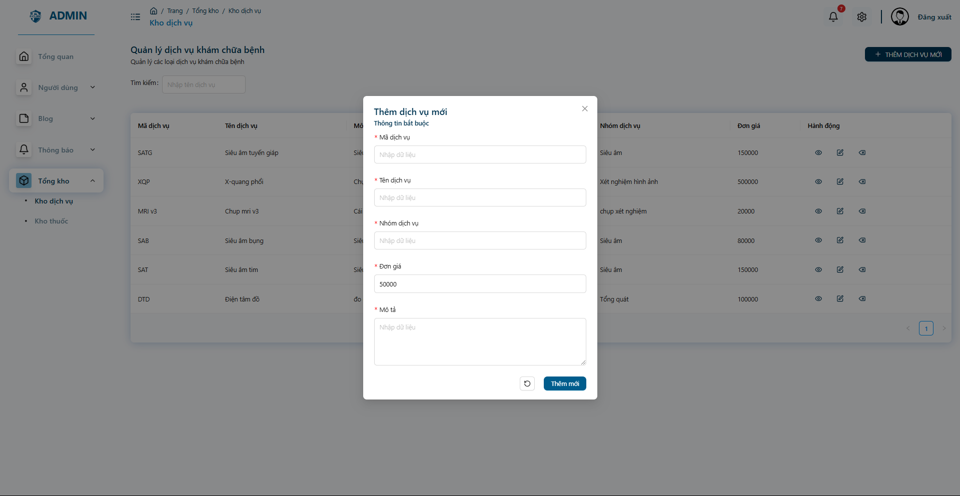

* Create new service information

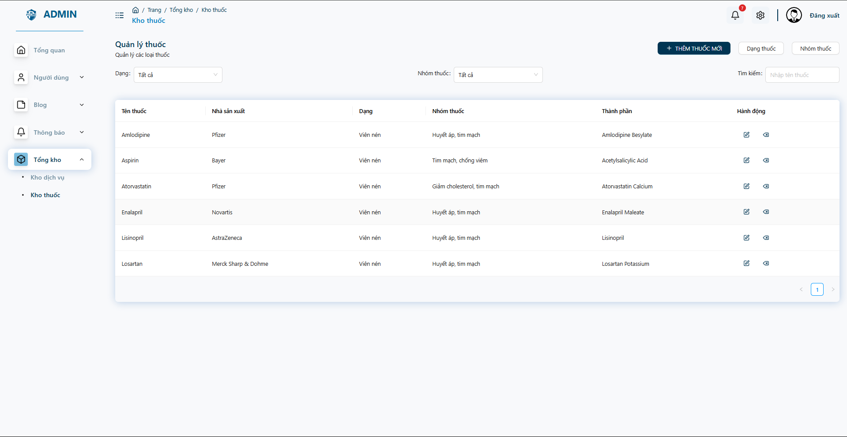

* Admin can manage all the medicines of the clinic

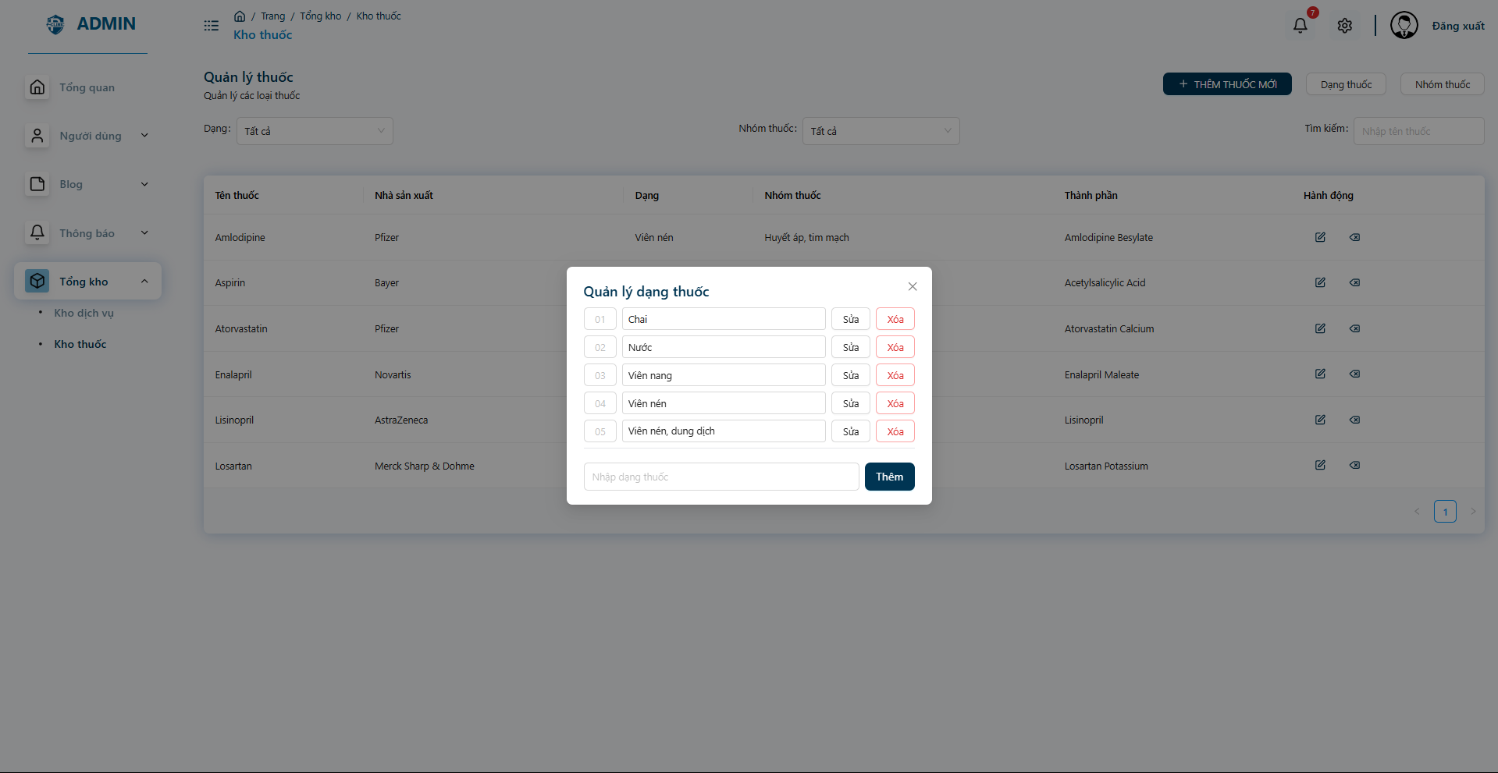

* Manage medicine type

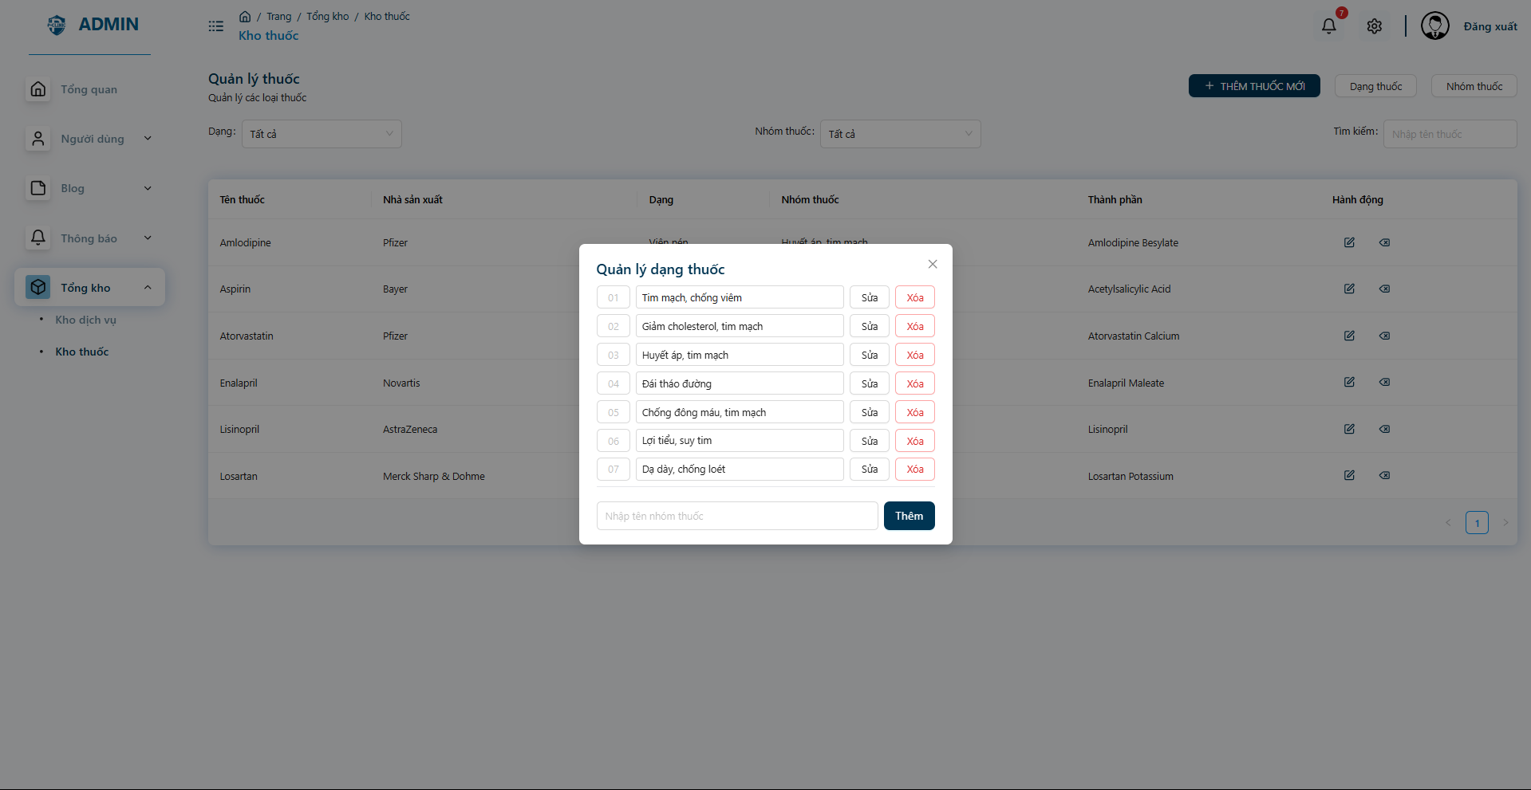

* Manage medicines group

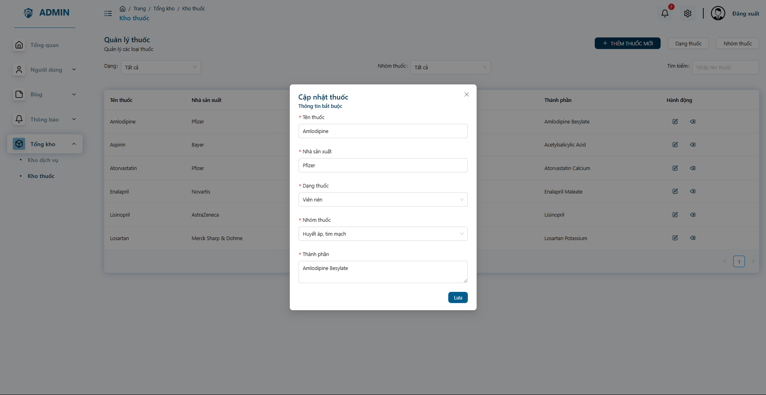

* Edit and view medicine informations

## 11. Workflow - Manage clinic

Admin screen

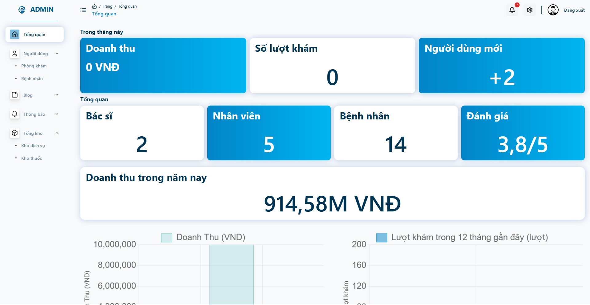

* Admin can view and follow the statistics information of the clinic

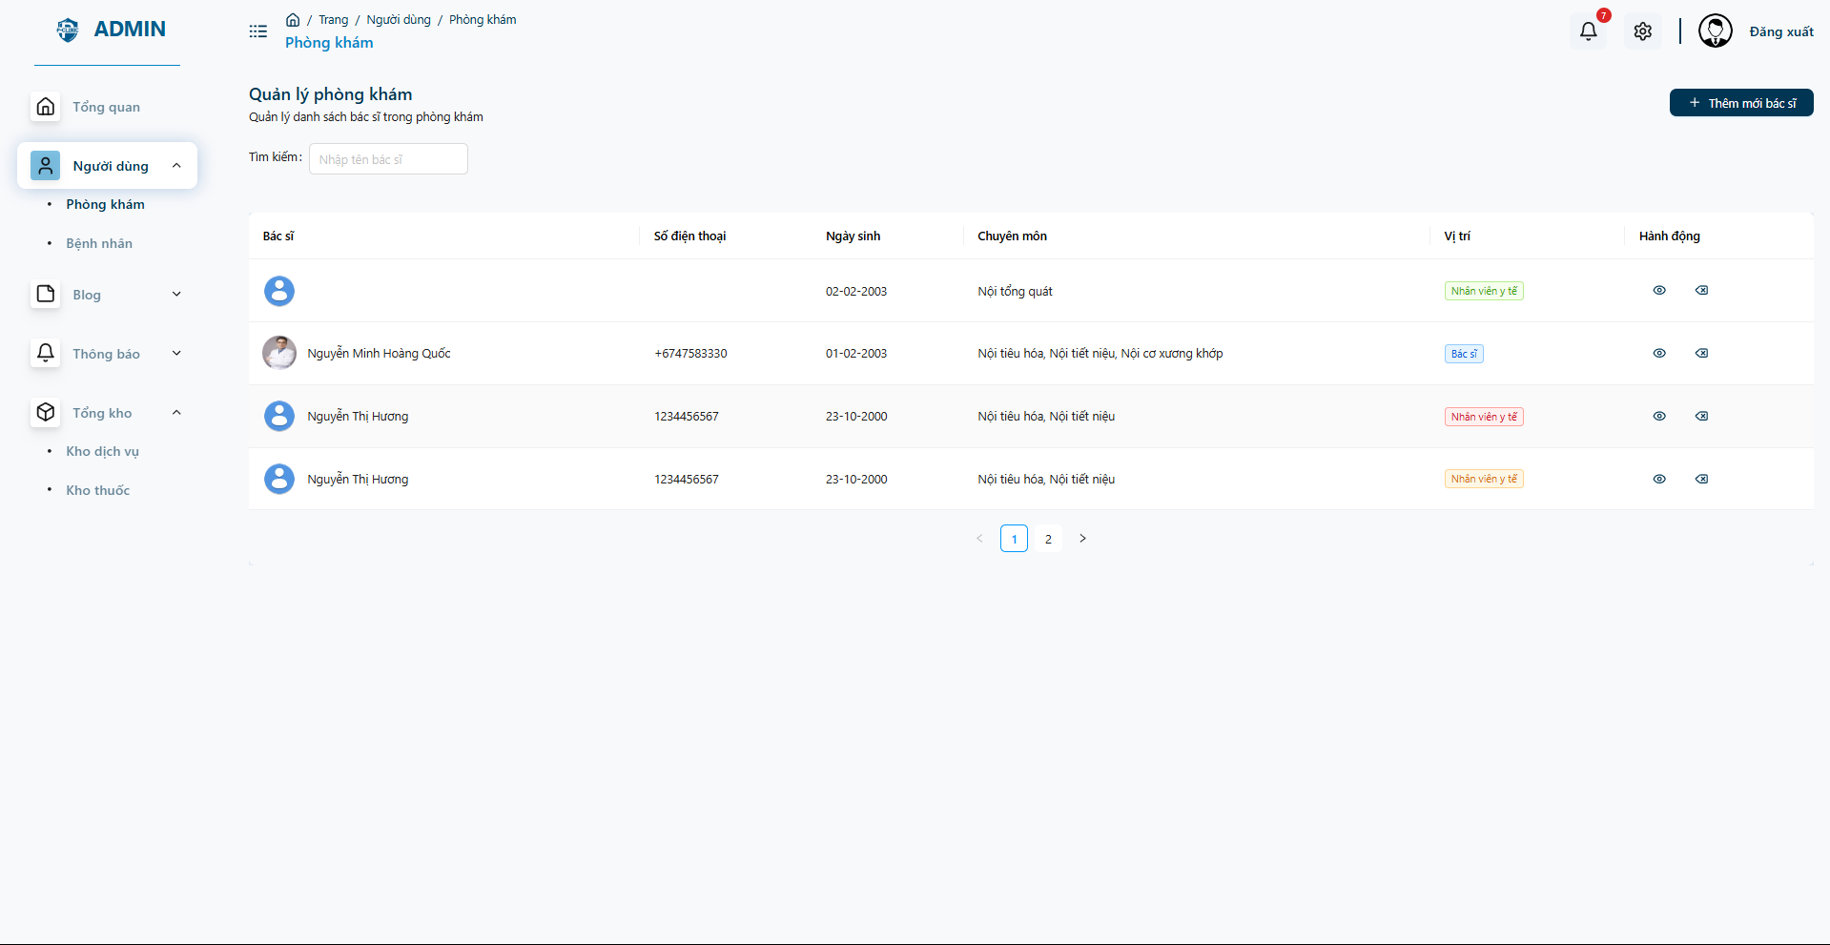

* Admin can follow and view list of clinic’s doctors

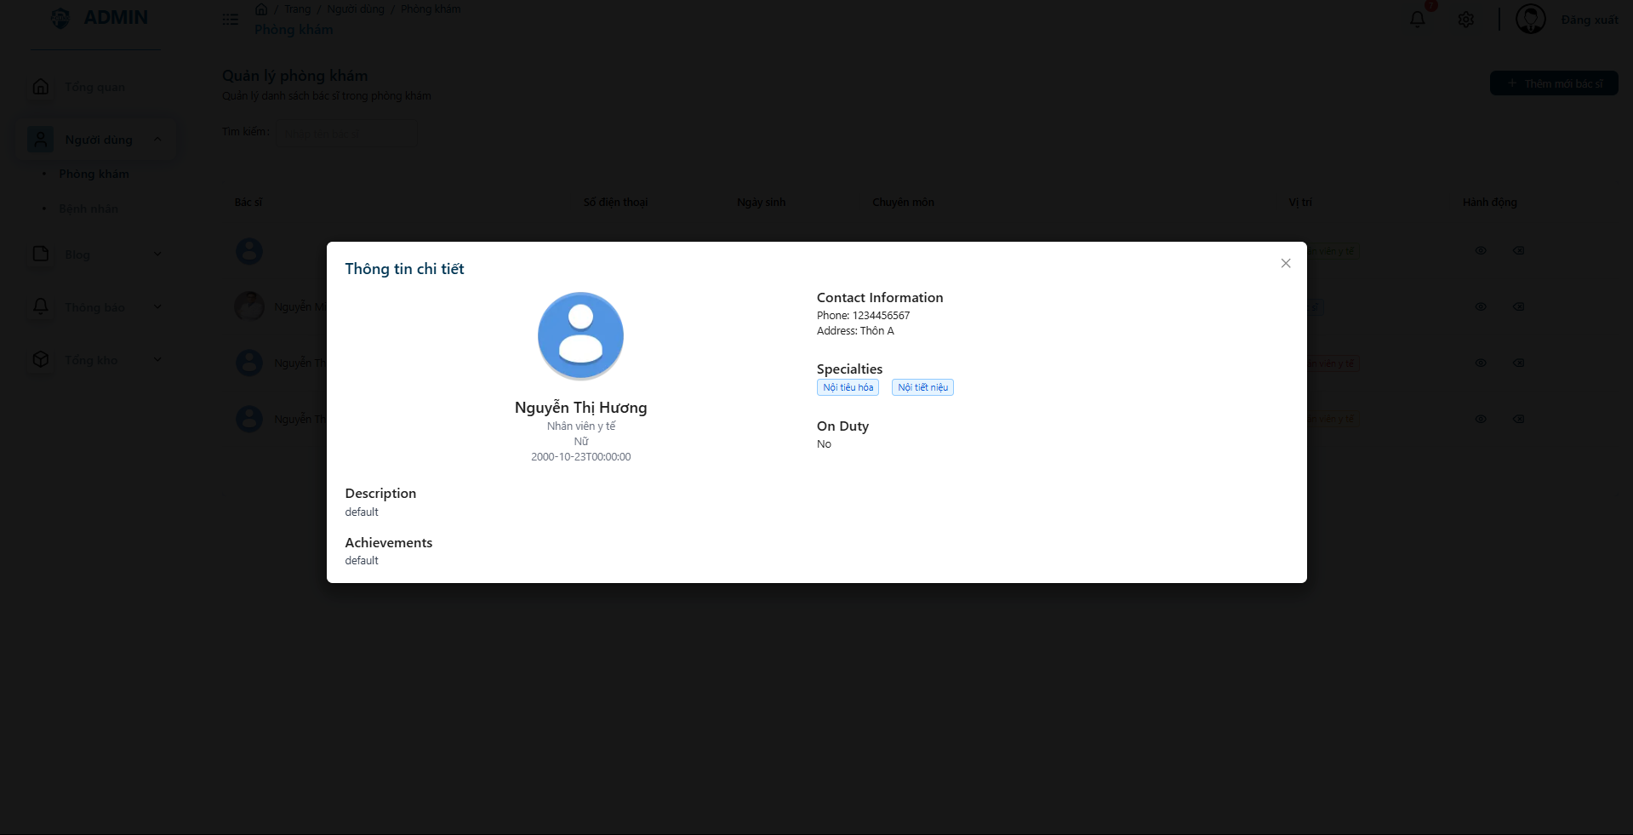

* View detail information of the doctor

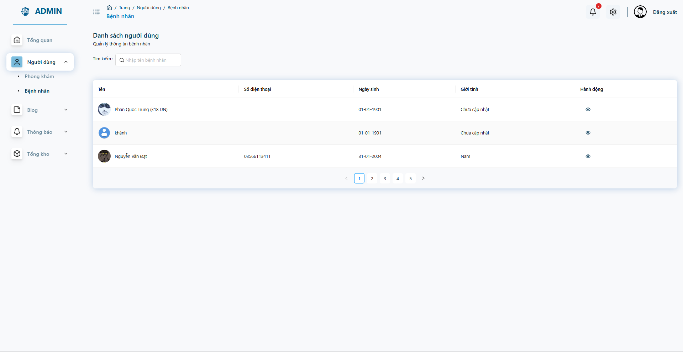

* Admin can follow and view list of clinic’s patients

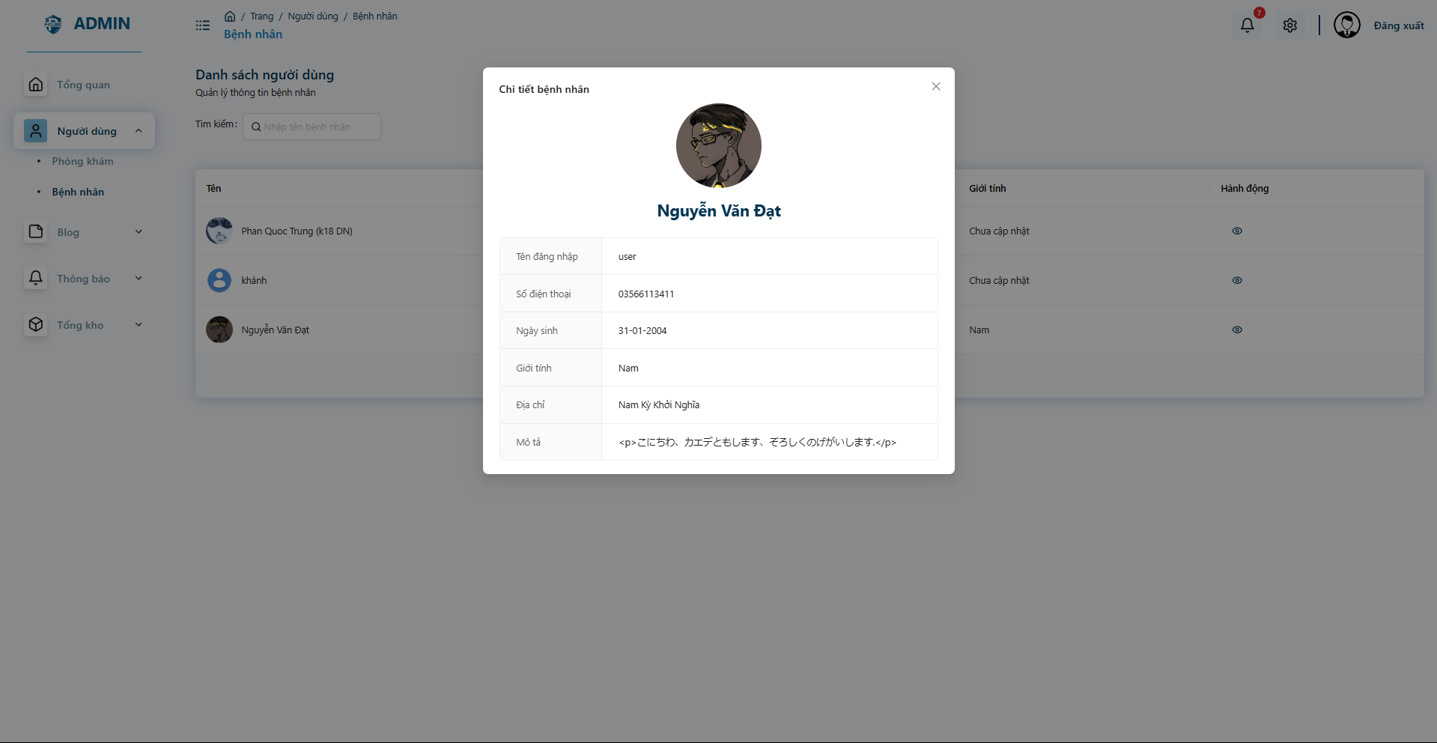

* Detail information of patients

## 12. Workflow - Medical Articles

**Admin screen**

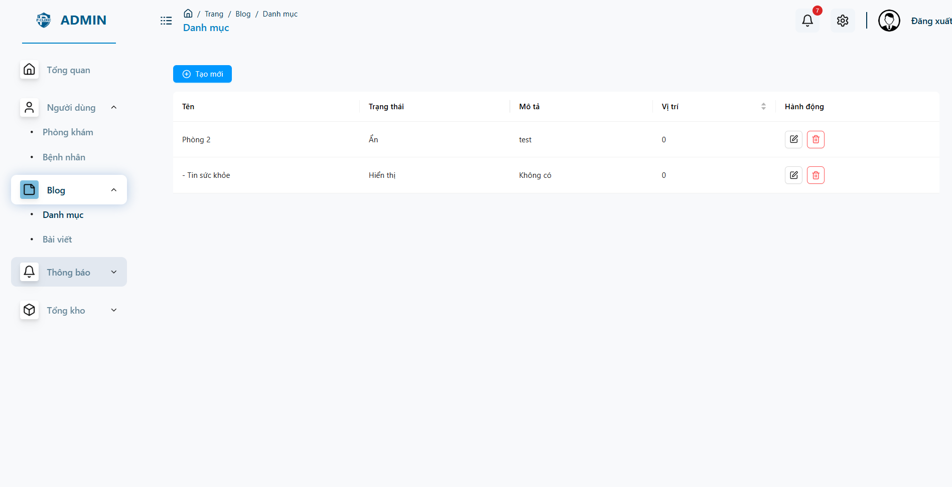

* **Admin can manage category of the medical articles**

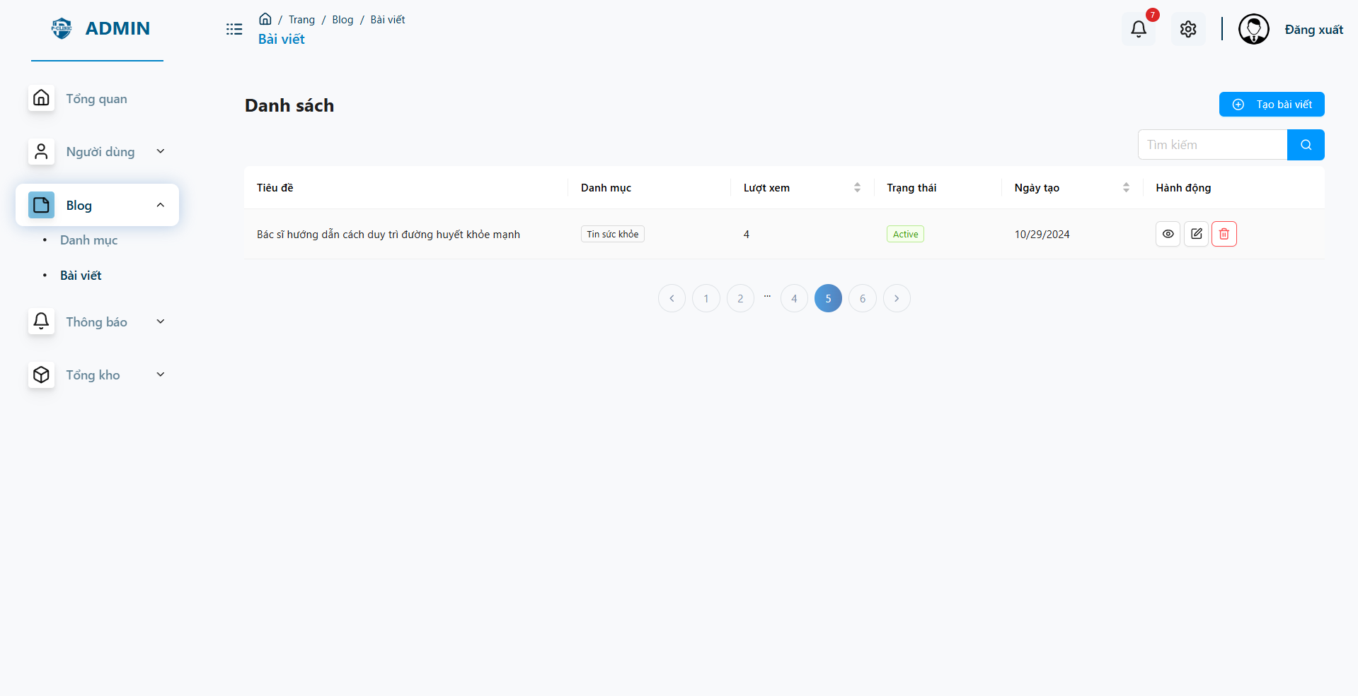

* **Admin, Doctor and Staff can view list of medical articles had post**

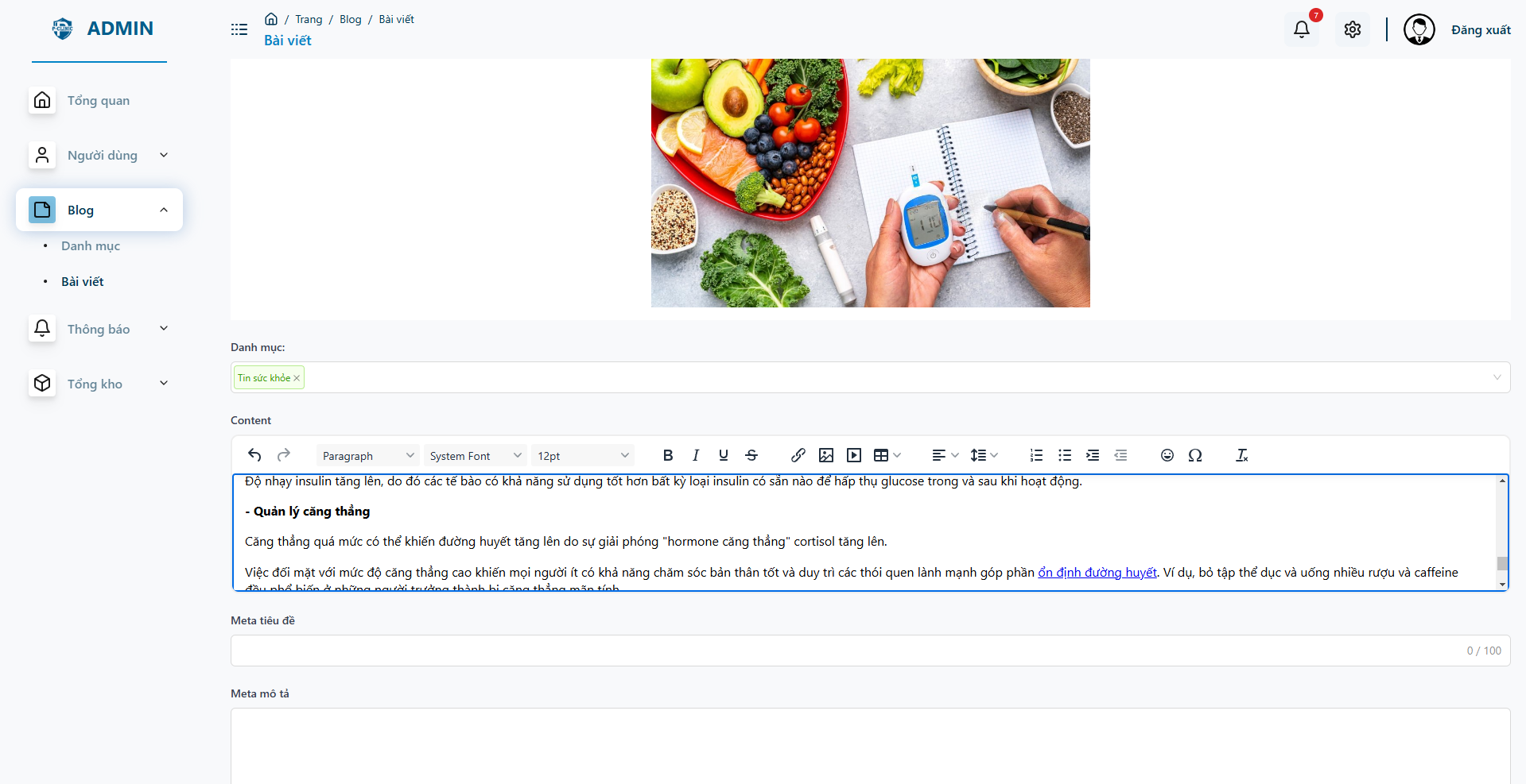

* **Admin, Doctor, Staff can update a post**

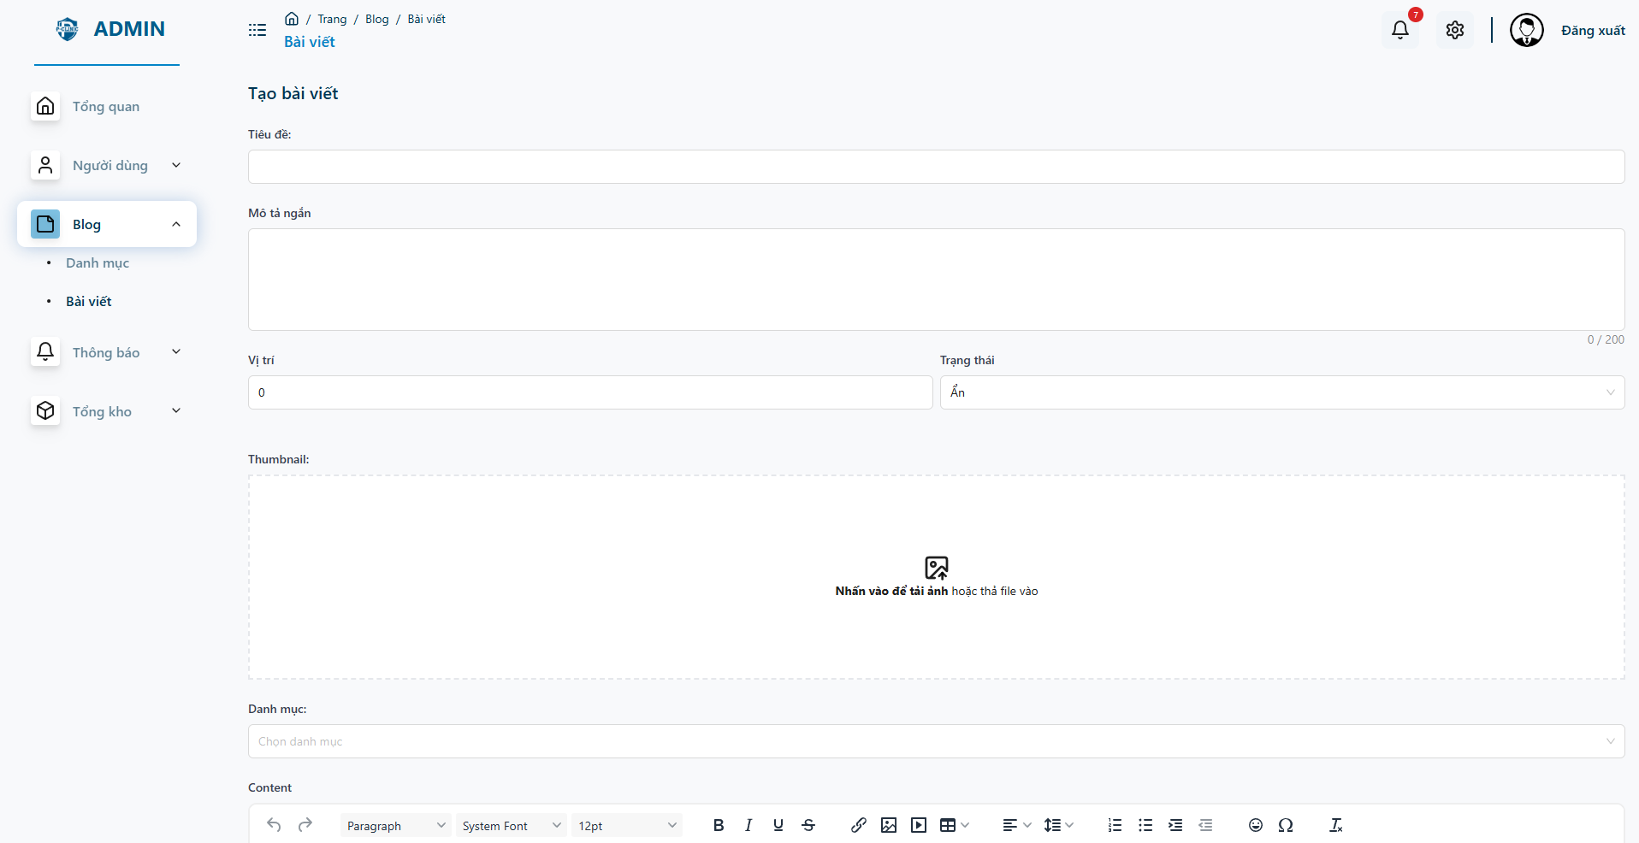

* **Admin, Doctor, Staff can create new post**

**Landing Page**

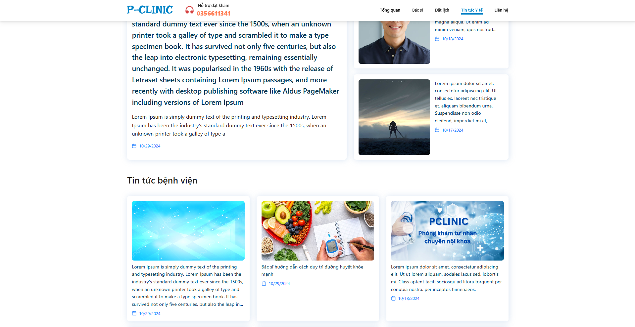

* **Guest user can find and read article on this page**

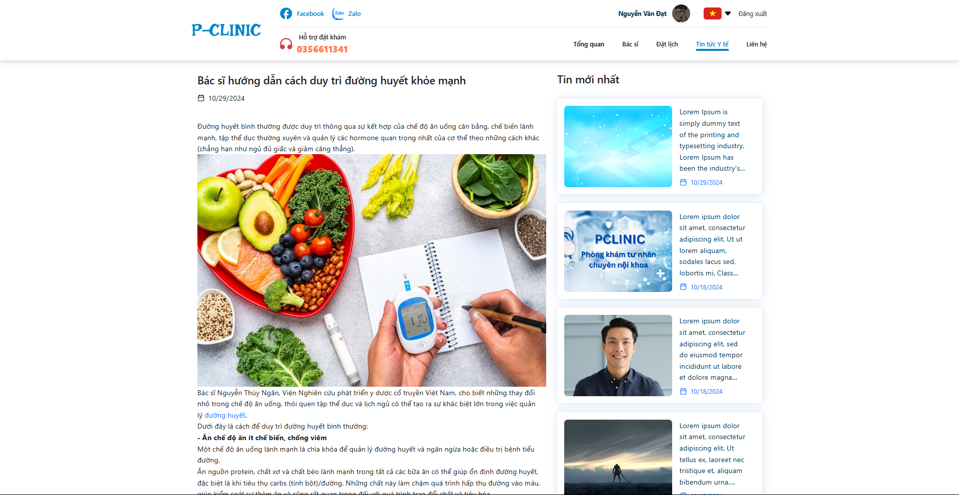

* **Article in detail page.**